Kansas Board of
Regents

Strengthening Career and Technical Education for the 21st Century Act

Carl D. Perkins
Program Improvement Grant

FY 2020

Local Application

Application Deadline: 5:00 p.m. C.D.T., May 13, 2019

Perkins Program Improvement Grant
2019-2020

Table of Contents

- Overview of Funding Opportunity 4

  - Statement of Purpose

2. Overview of Local Application 4
2.1 Local Application for Program Improvement Funds
2.2 Perkins Eligibility
2.3 Reporting Requirements
2.4 Revisions
2.5 Sanctions
2.6 Handbook
3. Expenditure Guidelines 6
3.1 Program Improvement Goals
3.2 Vendor Guidelines
3.3 Administrative Costs
3.4 Professional Development
3.5 Salaries
3.6 Equipment
3.7 On-Going Program Expenses
3.8 Allowable and Unallowable Expenditures
4. Program Improvement Elements – Mandatory Goals 8
5. Grant Submission Information 9

Appendix Documents
Appendix A 10
FY 2020 Perkins Program Improvement Grant Cover Page
Appendix B 11
Contractual Provisions
Appendix C 12
Local Assurances
Appendix D (for Consortiums only) 13
Transfer of Postsecondary Improvement Funds
Appendix E 14
Certifications Regarding Lobbying; Debarment, Suspension and other Responsibility Matters; And Drug-Free Workplace Requirements
Appendix I 16
Perkins Program Improvement Goals
Appendix J 24
Acquisition of Equipment (Unit Cost of $501-$4,999)
Appendix K 25
Acquisition of Equipment (Unit Cost of $5,000 or more)
Appendix L (Excel Sheet) Separate
Budget Matrix
Appendix M (Excel Sheet) Separate
Budgeted Breakdown of Expenses
Appendix N (Excel Sheet) Separate
Professional Development (Travel & Conferences)

1. Overview of Funding Opportunity
On July 31, 2018, President Trump signed the Strengthening Career and Technical Education for the 21st Century Act (Perkins V) into law. This Act reauthorizes the Carl D. Perkins Career and Technical Education Act of 2006 (Perkins IV). Perkins V is dedicated to increasing learner access to high-quality career technical education programs of study. With a focus on systems alignment and program improvement, this law has been critical to ensuring programs meet the ever-changing needs of learners and employers. Perkins funding supports a variety of elements, including professional development and technical assistance; creation of innovative programs of study; support for continuous improvement of existing programs of study; career exploration; guidance and advisement; data collection and analysis; and program evaluation and monitoring.

2. Overview of Local Application
To accomplish the legislated purpose, the eligible institutions must focus on the continuous improvement of career and technical education programs. The extent of program improvement is measured by the core indicators of the performance accountability system.

2.1. Local Application for Program Improvement Funds
Perkins funds must be used to improve career and technical education programs through the implementation or refinement of grant goals (Appendix I). As a reminder, Perkins funds may ONLY be spent on KBOR Perkins-approved career and technical education programs.

2.2. Perkins Eligibility
2.2.a. Eligible Institutions
Eligible institution is defined as “a public or nonprofit private institution of higher education that offers and will use funds provided under this title in support of career and technical education courses that lead to technical skill proficiency or a recognized postsecondary credential, including an industry-recognized credential, a certificate, or an associate degree, except that, for the purpose of section 132, the term ‘‘recognized postsecondary credential’’ as used in this subparagraph shall not include a baccalaureate degree” [Sec. 3(20)(B)].

2.2.b. Eligible Programs
Any program receiving Perkins Program Improvement funds must be designated as an eligible program by KBOR. A Perkins-approved Program must meet all KBOR Perkins eligibility requirements, including:
- At least 51% tiered
- Maintaining an average of 6 concentrators over 2 years
- Complying with Program Alignment
Short-term Stand Alone Parent Programs (SAPPs) must meet the following criteria:
- At least 80% tiered
- Composed of at least 8 credit hours
- Maintaining an average of 6 concentrators over 2 years

2.3. Reporting Requirements
Perkins Grant Progress Reports are due on December 1, 2020 and March 1, 2020 with a final report due on August 16, 2020 (FY20 Final Report).
- Progress reports should include updated Perkins Program Improvement Goals (Appendix I), a Budgeted Breakdown of Expenses spreadsheet (Appendix M) and a Budget Matrix report (Appendix L). These progress reports should provide detailed information on progress of each goal, the status of pending activities and total expenditures to date.
- In addition to the required reporting documents, the final report should also include Time and Effort reports, purchased equipment report, advisory board meeting calendar, and one set of minutes from each programs’ advisory board.

2.4. Revisions
Revisions to approved expenditures are subject to KBOR approval and require the submission of a Revision Request form and/or a Budgeted Breakdown of Expenses, based on the following guidelines:
- Revisions within the same goal in Appendix I with no change to the overall budget may be requested with the Revision Request form (no breakdown of expenses required).
- Revisions from one goal to another in Appendix I or from one expenditure category to another (e.g. salary to equipment) require the Revisions Request form and a revised Breakdown of Expenditures Report.
- If changes are made to professional development activities, they should be reflected in Appendix N.
- All revision requests must be submitted on or before May 17, 2020.

2.5. Sanctions
If the State fails to achieve, at an acceptable rate, the federal agreed-upon performance level for any of the core indicators, the State risks federal sanctions including a reduction of funds. The State’s performance percentages reflect those of all participating eligible institutions. Failure of an institution to achieve the targeted percentages potentially penalizes Kansas and all of the eligible recipients through the loss of Perkins funding.

If a local institution fails to achieve, at an acceptable rate, the state/locally agreed upon performance level for any of the core indicators, the Kansas Board of Regents may, after notice and opportunity for a hearing, withhold a portion or all of the Perkins allotment of a local institution.
Sanctions may be imposed for any grant management non-compliance issue, including fiscal, data and program goals.

2.6. Handbook
For further information on the Perkins Program Improvement Grant, please see the “Perkins Grant Handbook” at www.kansasregents.org.

3. Expenditure Guidelines

3.1. Program Improvement Goals—All mandated goals of Perkins V must be
addressed on the Program Improvement Goals appendix (Appendix I). Goals can be funded from either federal or nonfederal sources. When non-Perkins funds are used to support a goal, simply identify the source in the funding column (e.g. Local funding). Do not put $0 in the funding cell. Instead, use terms “local funds” or “institutional.”

3.2. Vendor Guidelines – Local institution certifies by its representative’s signature on the final application that neither it nor vendors used in expenditures of Carl D. Perkins grant funds are presently debarred, suspended, proposed for disbarment, declared ineligible, or voluntarily excluded from participation in this Agreement by any federal or state department or agency. Vendor verification can be done at www.sam.gov, click “Search Records.”

3.3. Administrative Costs No more than 5% of the total Perkins grant may be used for local administration. The Kansas Board of Regents interprets this as indirect costs related to the supervision, accounting and reporting of Perkins goals set forth in the local plan. Administrative costs must be accounted for just like expenditures in the program part of the grant.

3.4. Professional Development Institutions may identify a list or “pool” of professional development for instructors in Perkins-approved programs, which is submitted with the local application. This list does not have to include faculty names, locations of conference, dates, etc., but must be clearly identifiable (or include explanation of relevance) as to what type of conference, training, etc., it is, and what approved program it relates to. The institution may assign a lump sum and attach a list to the local application.
- All events may not be attended during the plan year, but this flexibility should ease the revision process, and changes made by faculty and outside parties.
- Any new professional development requested that is not pre-approved must go through the approval process with KBOR.

3.5. Salaries—No more than 50% of the total Perkins grant may be used for salaries. Funding may only be used for new, permanent positions that will be assumed by the institution when grant funding is no longer available (maximum 3 years). Approved Perkins funding will decrease by 1/3 each year for the 2nd and 3rd years the position is funded. Any funded new positions cannot be used to supplant existing personnel expenditures. A complete job/position description with time allocations must be submitted with the grant application (every year of the three-year rolldown). The roll down of salaries can only be for the actual amount paid out the previous year.

3.6. Equipment—No more than 50% of the total Perkins grant may be used to purchase equipment. Equipment expenditures must be for new equipment to enhance an approved CTE program and cannot be used for maintenance or replacement of existing worn-out equipment.
- OPTIONAL EQUIPMENT POOL – Institutions may identify a list of equipment that they may want to purchase by the deadline of December 31. Equipment in this pool may not all be purchased during the year, but gives institutions the flexibility to adjust purchases when/if there are extra funds available. If equipment is pre-approved, no revision request is required
- For reporting and compliance purposes, detailed description of the purpose and uses of the equipment should be provided on the application, progress and final reports.
- Equipment brand name is not required when submitting the local application, but the type of equipment, the program it is intended for and the use must be clearly stated, which eliminates any need to submit a Revision Request if brand purchased is different than what was submitted in application.

3.7. On-Going Program Expenses—Items essential to delivering effective, quality CTE programs should over time be assumed by the institution. Perkins Program Improvement funds are to be used for improvements, not to simply maintain the operation of a CTE program or service provided by the institution. Approved Perkins funding for items such as annual renewals for software/hardware licenses for instructional software or student screening/placement assessments (e.g. Compass, Plato, Discover, Choices, TABE, WorkKeys) will be decreased by 1/3 each year over a 3-year period to assist institutions in assuming these program costs.

3.8. Allowable and Unallowable Expenditures -The following allowable and unallowable expenditures apply to all grant goals. Please note, this list is not all inclusive. Please contact KBOR with questions on allowable expenditures.

Allowable Expenditures |  | Unallowable Expenditures
Accounting |  | Any cost not allocable to specific programs
Advisory Councils/Committees |  | Any costs not necessary and reasonable
Assessments |  | Bad Debts
Building Lease Management |  | Canned Curriculum
Career Guidance/Counseling |  | Consumables (paper, toner, etc.)
Central Stores |  | Contingencies
Consultants |  | Contributions/Donations
Curriculum Development |  | Entertainment
Equipment (industry standard) |  | Food
Equipment maintenance (if part of initial purchase) |  | General Expenses required to carry out overall program responsibilities of
Employee Salary & Fringe Benefits  (subject to 3 year rolldown) |  | Interest and other financial costs
Subscriptions and professional activities |  | Legislative Expenses
Personnel Administration |  | Promotional “give away” items
Professional Development Activities |  | Student Internships
Teacher Internships |  | Student Scholarships
Travel |  | Student Transportation
CTSO Advisor Support |  | Textbooks, Tuition
Substitutes |  | CTSO Student Support
Allowable Expenditures
Advertising  Communications  Printing and Reproduction | These expenditures are allowable ONLY for the nontraditional  and special populations’ activities. In addition, all expenditures  must be approved by KBOR before funds are expended. Failure to request and receive KBOR approval will result in the return of any expended funds as well as fiscal sanctions.

4. Program Improvement Elements
The Application includes Perkins Program Improvement Goals (Appendix I) for each of the Perkins V elements required by the law. Each institution seeking Perkins funding must address all mandatory goals in the application and reports, but may use institutional or Perkins funds to achieve those goals.

- Career Exploration and Career Guidance
a description of how the eligible recipient, in collaboration with local workforce development boards and other local workforce agencies, one-stop delivery systems described in section 121(e)(2) of the Workforce Innovation and Opportunity Act (29 U.S.C. 3151(e)(2)), and other partners, will provide—
(A) career exploration and career development coursework, activities, or services;
(B) career information on employment opportunities that incorporate the most up-to-date information on high-skill, high-wage, or in-demand industry sectors or occupations, as determined by the comprehensive needs assessment described in subsection (c); and
(C) an organized system of career guidance and academic counseling to students before enrolling and while participating in a career and technical education program [Sec. 134(b)(3)].
- Integration of Academics and CTE
a description of how the eligible recipient will improve the academic and technical
skills of students participating in career and technical education programs by strengthening the academic and career and technical education components of such programs through the integration of coherent and rigorous content aligned with challenging academic standards and relevant career and technical education programs to ensure learning in the subjects that constitute a well-rounded education (as defined in section 8101 of the Elementary and Secondary Education Act of 1965) [Sec. 134(b)(4)].
- Special Populations
a description of how the eligible recipient will—
(A) provide activities to prepare special populations for high-skill, high-wage, or
in-demand industry sectors or occupations that will lead to self-sufficiency;
(B) prepare CTE participants for non-traditional fields;
(C) provide equal access for special populations to career and technical education
courses, programs, and programs of study; and
(D) ensure that members of special populations will not be discriminated against
on the basis of their status as members of special populations [Sec. 134(b)(5)].

- Work-based Learning
a description of the work-based learning opportunities that the eligible recipient will
provide to students participating in career and technical education programs and how the recipient will work with representatives from employers to develop or expand work-based learning opportunities for career and technical education students, as applicable [Sec. 134(b)(6)].
- Secondary/Postsecondary Alignment
a description of how the eligible recipient will provide students participating in career
and technical education programs with the opportunity to gain postsecondary credit while still attending high school, such as through dual or concurrent enrollment programs or early college high school, as practicable [Sec. 134(b)(7)].
- Professional Development
a description of how the eligible recipient will coordinate with the eligible agency and institutions of higher education to support the recruitment, preparation, retention, and training, including professional development, of teachers, faculty, administrators, and specialized instructional support personnel and paraprofessionals who meet applicable State certification and licensure requirements (including any requirements met through alternative routes to certification), including individuals from groups underrepresented in the teaching profession [Sec. 134(b)(8)].
(7) Use of Technology
a description of how the eligible recipient will use technology/equipment purchased with Perkins grants to meet Goals (1) through (6) of this application.
(8) Administration
A description of how Administration funds (5%) will be used during the grant year (if applicable).

5. Submission Information
A signed copy of the entire Local Application for Program Improvement Funds must be submitted by May 13, 2019. The final document, with all signatures, may be emailed to Vera Brown at vbrown@ksbor.org or Tobias Wood at twood@ksbor.org. No hardcopy will be required. You will receive a final copy with KBOR signatures upon final approval.

Complete submission checklist, president’s signature and preparer’s signature are required.

Required documents:

- Appendix A
- Appendix B
- Appendix C
- Appendix D (Consortiums Only)
- Appendix E
- Appendix I
- Appendix J
- Appendix K
- Appendix L
- Appendix M
- Appendix N

Appendix A
FY 2020 LOCAL APPLICATION FOR POSTSECONDARY
PERKINS PROGRAM IMPROVEMENT FUNDS

Institution Name

Postsecondary Funding: I understand that if funds become unavailable, this application may be terminated. If satisfactory progress and documentation are not made regarding the intended outcomes of the application, this application becomes null and void and all funds must be returned. I further understand that supplanting of funds is not allowed under the Carl D. Perkins Career and Technical Education Act of 2006.

Contact Persons for
 | Name & Position | Telephone & Fax | Email Address
Perkins Grant Application, Management and Reports
Finance / Business Office

Authorized Administrator—Original Signature Date
Submission Checklist
☐ | Appendix A, Cover Page (Signed) |  |  | ☐ | Appendix I, Program Improvement Goals
☐ | Appendix B, Contractual Provisions |  |  | ☐ | Appendix J, Proposed Equipment < $5,000
☐ | Appendix C, Local Assurances (Signed) |  |  | ☐ | Appendix K, Proposed Equipment > $5,000
☐ | Appendix D, Transfer of Funds (Consortiums only, Signed) |  |  | ☐ | Appendix L, Program Budget Matrix (Signed)
☐ | Appendix E, Certifications (Institutional Address Added in 3.B. & Signed) |  |  | ☐ | Appendix M, Budgeted Breakdown of Expenses, (Part B Signed)
 |  |  |  | ☐ | Appendix N, Professional Development
STATE USE ONLY—DO NOT WRITE BELOW THIS LINE

$_____________________ (1) Career Exploration and Career Guidance
$_____________________ (2) Integration of Academics and CTE
$_____________________ (3) Special Populations
$_____________________ (4) Work-based Learning
$_____________________ (5) Secondary/Postsecondary Alignment
$_____________________ (6) Professional Development
$_____________________ (7) Use of Technology
$_____________________ (8) Administrative Costs
$_____________________ Total

KBOR Authorized Representative Date

Appendix B (FY20)
State of Kansas
Department of Administration
DA-146a (Rev. 06-12)
CONTRACTUAL PROVISIONS ATTACHMENT

Important: This form contains mandatory contract provisions and must be attached to or incorporated in all copies of any contractual agreement. If it is attached to the vendor/contractor's standard contract form, then that form must be altered to contain the following provision:

"The Provisions found in Contractual Provisions Attachment (Form DA-146a, Rev. 06-12), which is attached hereto, are hereby incorporated in this contract and made a part thereof."

The parties agree that the following provisions are hereby incorporated into the contract to which it is attached and made a part thereof, said contract being the _1st_ day of ___July_______, 2019____.
1. Terms Herein Controlling Provisions: It is expressly agreed that the terms of each and every provision in this attachment shall prevail and control over the terms of any other conflicting provision in any other document relating to and a part of the contract in which this attachment is incorporated. Any terms that conflict or could be interpreted to conflict with this attachment are nullified.

2. Kansas Law and Venue: This contract shall be subject to, governed by, and construed according to the laws of the State of Kansas, and jurisdiction and venue of any suit in connection with this contract shall reside only in courts located in the State of Kansas.

3. Termination Due To Lack Of Funding Appropriation: If, in the judgment of the Director of Accounts and Reports, Department of Administration, sufficient funds are not appropriated to continue the function performed in this agreement and for the payment of the charges hereunder, State may terminate this agreement at the end of its current fiscal year. State agrees to give written notice of termination to contractor at least 30 days prior to the end of its current fiscal year, and shall give such notice for a greater period prior to the end of such fiscal year as may be provided in this contract, except that such notice shall not be required prior to 90 days before the end of such fiscal year. Contractor shall have the right, at the end of such fiscal year, to take possession of any equipment provided State under the contract. State will pay to the contractor all regular contractual payments incurred through the end of such fiscal year, plus contractual charges incidental to the return of any such equipment. Upon termination of the agreement by State, title to any such equipment shall revert to contractor at the end of the State's current fiscal year. The termination of the contract pursuant to this paragraph shall not cause any penalty to be charged to the agency or the contractor.

4. Disclaimer Of Liability: No provision of this contract will be given effect that attempts to require the State of Kansas or its agencies to defend, hold harmless, or indemnify any contractor or third party for any acts or omissions. The liability of the State of Kansas is defined under the Kansas Tort Claims Act (K.S.A. 75-6101 et seq.).

5. Anti-Discrimination Clause: The contractor agrees: (a) to comply with the Kansas Act Against Discrimination (K.S.A. 44-1001 et seq.) and the Kansas Age Discrimination in Employment Act (K.S.A. 44-1111 et seq.) and the applicable provisions of the Americans With Disabilities Act (42 U.S.C. 12101 et seq.) (ADA) and to not discriminate against any person because of race, religion, color, sex, disability, national origin or ancestry, or age in the admission or access to, or treatment or employment in, its programs or activities; (b) to include in all solicitations or advertisements for employees, the phrase "equal opportunity employer"; (c) to comply with the reporting requirements set out at K.S.A. 44-1031 and K.S.A. 44-1116; (d) to include those provisions in every subcontract or purchase order so that they are binding upon such subcontractor or vendor; (e) that a failure to comply with the reporting requirements of (c) above or if the contractor is found guilty of any violation of such acts by the Kansas Human Rights Commission, such violation shall constitute a breach of contract and the contract may be cancelled, terminated or suspended, in whole or in part, by the contracting state agency or the Kansas Department of Administration; (f) if it is determined that the contractor has violated applicable provisions of ADA, such violation shall constitute a breach of contract and the contract may be cancelled, terminated or suspended, in whole or in part, by the contracting state agency or the Kansas Department of Administration.

Contractor agrees to comply with all applicable state and federal anti-discrimination laws.

The provisions of this paragraph number 5 (with the exception of those provisions relating to the ADA) are not applicable to a contractor who employs fewer than four employees during the term of such contract or whose contracts with the contracting State agency cumulatively total $5,000 or less during the fiscal year of such agency.

6. Acceptance Of Contract: This contract shall not be considered accepted, approved or otherwise effective until the statutorily required approvals and certifications have been given.

7. Arbitration, Damages, Warranties: Notwithstanding any language to the contrary, no interpretation of this contract shall find that the State or its agencies have agreed to binding arbitration, or the payment of damages or penalties. Further, the State of Kansas and its agencies do not agree to pay attorney fees, costs, or late payment charges beyond those available under the Kansas Prompt Payment Act (K.S.A. 75-6403), and no provision will be given effect that attempts to exclude, modify, disclaim or otherwise attempt to limit any damages available to the State of Kansas or its agencies at law, including but not limited to the implied warranties of merchantability and fitness for a particular purpose.

8. Representative's Authority To Contract: By signing this contract, the representative of the contractor thereby represents that such person is duly authorized by the contractor to execute this contract on behalf of the contractor and that the contractor agrees to be bound by the provisions thereof.

9. Responsibility For Taxes: The State of Kansas and its agencies shall not be responsible for, nor indemnify a contractor for, any federal, state or local taxes which may be imposed or levied upon the subject matter of this contract.

10. Insurance: The State of Kansas and its agencies shall not be required to purchase any insurance against loss or damage to property or any other subject matter relating to this contract, nor shall this contract require them to establish a "self-insurance" fund to protect against any such loss or damage. Subject to the provisions of the Kansas Tort Claims Act (K.S.A. 75-6101 et seq.), the contractor shall bear the risk of any loss or damage to any property in which the contractor holds title.

11. Information: No provision of this contract shall be construed as limiting the Legislative Division of Post Audit from having access to information pursuant to K.S.A. 46-1101 et seq.

12. The Eleventh Amendment: "The Eleventh Amendment is an inherent and incumbent protection with the State of Kansas and need not be reserved, but prudence requires the State to reiterate that nothing related to this contract shall be deemed a waiver of the Eleventh Amendment."

13. Campaign Contributions / Lobbying: Funds provided through a grant award or contract shall not be given or received in exchange for the making of a campaign contribution. No part of the funds provided through this contract shall be used to influence or attempt to influence an officer or employee of any State of Kansas agency or a member of the Legislature regarding any pending legislation or the awarding, extension, continuation, renewal, amendment or modification of any government contract, grant, loan, or cooperative agreement.
Appendix C (FY20)

LOCAL ASSURANCES

We, as an eligible recipient for funds under the Strengthening Career and Technical Education for the 21st Century Act (Perkins V), hereby grant the following assurances:

- Applicants submitting an application to the Kansas Board of Regents, certify they have read all application documents including any revised documents and agree to comply with all applicable federal requirements as outlined in the Strengthening Career and Technical Education for the 21st Century Act, subsequent federal requirements, state requirements, local laws, ordinances, rules and regulations, public policies herein and all others applicable

- To administer each program, service or activity covered in this application in accordance with all applicable statutes and regulations governing the Strengthening Career and Technical Education for the 21st Century Act

- No funds expended under the Act will be used to acquire equipment (including computer software) in any instance in which such acquisition results in a direct financial benefit to any organization representing the interests of the acquiring entity or the employees of the acquiring entity, or any affiliate of such an organization.

- Certifies by its representative’s signature hereon that neither it nor vendors used in expenditures with Carl D. Perkins grant funds are presently debarred, suspended, proposed for disbarment, declared ineligible, or voluntarily excluded from participation in this Agreement by any federal or state department or agency.

- To comply with all reporting requirements in a timely manner and that the information reported is valid, reliable and accurate.

- The determinations regarding the distribution of these grant funds are an agency action by the Kansas Board of Regents, an agency of the State of Kansas. In accordance with K.S.A. 77-601 et seq., The Kansas Board of Regents is hereby providing final notice that, with respect to the distribution of these funds, the board has taken final agency action. The distribution amount approved by the Board is set forth in this award notice.

- General Counsel Julene L. Miller is the agency officer who shall receive service on behalf of the Kansas Board of Regents of any subsequent petition for judicial review of this action. Any such petition for judicial review must be filed within 30 days of the date of this document.

- To be in compliance with Executive Order 12246; Title VI of the Civil rights Act of 1964, as amended; Title IX Regulations; Section 504 of the Rehabilitation Act of 1973, as amended; Individuals with Disabilities Education Act and any other federal or state laws, regulations and policies which apply to the operation of the programs.

We will not discriminate on the basis of sex, race, color, national origin or disability in the educational programs, services or activities being provided.

_____________________________________________________________________________________________________
Name of Institution

assures the Kansas Board of Regents its’ intent to comply with these Local Assurances as outlined in this document. Further, we are willing to explain, in writing, how we intend to comply with each of these assurances.

Signature of Authorized Administrator Title Date

Appendix D (consortiums only)

TRANSFER OF POSTSECONDARY IMPROVEMENT FUNDS
(CONSORTIUMS ONLY)

Use this form for transferring Strengthening Career and Technical Education for the 21st Century Act (Perkins V) postsecondary funds from one eligible recipient to another eligible recipient providing service on behalf of the institution. Submit an original copy for each institution transferring funds into a consortium/partnership.

I certify that

Transferring Institution Name

is transferring all postsecondary improvement funds made available under Strengthening Career and Technical Education for the 21st Century Act (Perkins V) for fiscal year 2020 to

Receiving Institution Name

The funds will be used as described in the program improvement grant application package of the receiving institution. The uses of funds must be mutually beneficial to Perkins-approved CTE programs at all institutions in the consortium.

________________________________ ______________________________
Original Signature of Authorized Original Signature of Authorized
Administrator Transferring Funds Administrator Receiving Funds

Date____________________________ Date __________________________

**************************

STATE USE ONLY
***************************

I hereby certify that the transferring institution is eligible for the funds identified above and the receiving institution is eligible to receive said funds.

_________________________________________ Date___________________________
Signature of KBOR Authorized Representative
Appendix E (FY20)
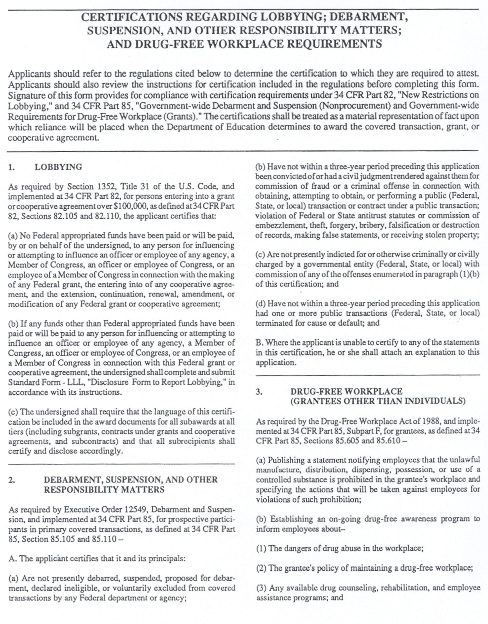

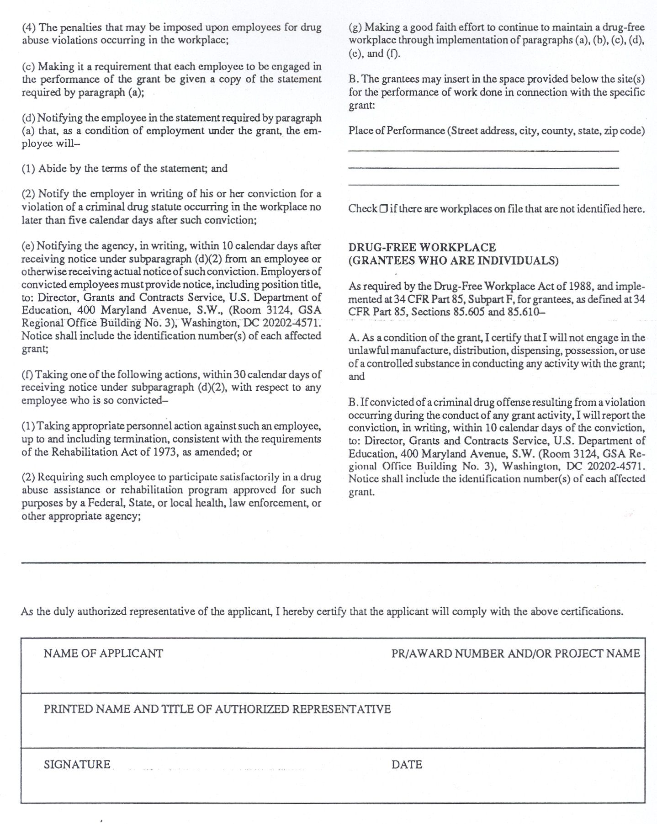

Appendix I Institution: _______________________________

PERKINS PROGRAM IMPROVEMENT GOALS

Goal 1: Career Exploration and Career Guidance
How will your institution, in collaboration with local workforce development boards and other local workforce agencies, provide career exploration and career guidance to students? [Perkins V Sec. 134(b)(3)].

Line #  1 | Description of the Activity | Funding  $
 | Responsibility: Timeline:
 | Evaluation/Measures:
Dec 1
Mar 1
Final
Outcomes

Line #  2 | Description of the Activity | Funding  $
 | Responsibility: Timeline:
 | Evaluation/Measures:
Dec 1
Mar 1
Final
Outcomes
Total Perkins Funding Requested for Goal 1: $

PERKINS PROGRAM IMPROVEMENT GOALS

Goal 2: Integration of Academics and CTE
How will your institution improve the academic and technical skills of students
participating in career and technical education programs? [Perkins V Sec. 134(b)(4)].

Line #  1 | Description of the Activity | Funding  $
 | Responsibility: Timeline:
 | Evaluation/Measures:
Dec 1
Mar 1
Final
Outcomes

Line #  2 | Description of the Activity | Funding  $
 | Responsibility: Timeline:
 | Evaluation/Measures:
Dec 1
Mar 1
Final
Outcomes

Total Perkins Funding Requested for Goal 2: $ j

PERKINS PROGRAM IMPROVEMENT GOALS

Goal 3: Special Populations
How will your institution provide activities to prepare special populations for high-skill, high-wage, or in-demand industry sectors, prepare CTE participants for non-traditional fields, provide equal access, and ensure non-discrimination? [Perkins V Sec. 134(b)(5)].

Line #  1 | Description of the Activity | Funding  $
 | Responsibility: Timeline:
 | Evaluation/Measures:
Dec 1
Mar 1
Final
Outcomes

Line #  2 | Description of the Activity | Funding  $
 | Responsibility: Timeline:
 | Evaluation/Measures:
Dec 1
Mar 1
Final
Outcomes

Total Perkins Funding Requested for Goal 3: $ j

PERKINS PROGRAM IMPROVEMENT GOALS

Goal 4: Work-based Learning
How will your institution provide work-based learning opportunities to students?
[Perkins V Sec. 134(b)(6)].

Line #  1 | Description of the Activity | Funding  $
 | Responsibility: Timeline:
 | Evaluation/Measures:
Dec 1
Mar 1
Final
Outcomes

Line #  2 | Description of the Activity | Funding  $
 | Responsibility: Timeline:
 | Evaluation/Measures:
Dec 1
Mar 1
Final
Outcomes

Total Perkins Funding Requested for Goal 4: $ j

PERKINS PROGRAM IMPROVEMENT GOALS

Goal 5: Secondary/Postsecondary Alignment
How will your institution provide students participating in CTE programs with the opportunity to gain postsecondary credit while still attending high school?
[Perkins V Sec. 134(b)(7)].

Line #  1 | Description of the Activity | Funding  $
 | Responsibility: Timeline:
 | Evaluation/Measures:
Dec 1
Mar 1
Final
Outcomes

Line #  2 | Description of the Activity | Funding  $
 | Responsibility: Timeline:
 | Evaluation/Measures:
Dec 1
Mar 1
Final
Outcomes

Total Perkins Funding Requested for Goal 5: $ j

PERKINS PROGRAM IMPROVEMENT GOALS

Goal 6: Professional Development
How will your institution provide training and professional development of Perkins-approved CTE program faculty, staff, and specialized instructional support personnel?
[Perkins V Sec. 134(b)(8)].

Line #  1 | Description of the Activity | Funding  $
 | Responsibility: Timeline:
 | Evaluation/Measures:
Dec 1
Mar 1
Final
Outcomes

Line #  2 | Description of the Activity | Funding  $
 | Responsibility: Timeline:
 | Evaluation/Measures:
Dec 1
Mar 1
Final
Outcomes

Total Perkins Funding Requested for Goal 6: $ j

PERKINS PROGRAM IMPROVEMENT GOALS

Goal 7: Use of Technology/Equipment
How will your institution use technology/equipment purchased with Perkins grant funds to achieve Goals (1) through (6) of this application?

Line #  1 | Description of the Activity | Funding  $
 | Responsibility: Timeline:
 | Evaluation/Measures:
Dec 1
Mar 1
Final
Outcomes

Line #  2 | Description of the Activity | Funding  $
 | Responsibility: Timeline:
 | Evaluation/Measures:
Dec 1
Mar 1
Final
Outcomes

Total Perkins Funding Requested for Goal 7: $ j

PERKINS PROGRAM IMPROVEMENT GOALS

Goal 8: Administrative Costs
How will your institution use Perkins funds toward administration of the Program Improvement grant (maximum of 5%)?

Line #  1 | Description of the Activity (Required for approval) | Funding  $
 | Responsibility: Timeline:
 | Evaluation/Measures:
Dec 1
Mar 1
Final
Outcomes

Total Perkins Funding Requested for Goal 8: $ j

Appendix J
FY 20 Perkins Program Improvement Grant

Proposed Acquisitions of Equipment (Unit Cost of $501 - $4,999)

Institution: _____________________________________

Description | Number of Items | Unit Cost | Total Cost | Program Name, CIP & Location  (Campus, Building)
Optional Equipment Pool
(May be purchased without a revision if funds become available)

Appendix K
FY20 Perkins Program Improvement Grant

Proposed Acquisitions of Equipment (Unit Cost of $5,000 or More)

Institution: _____________________________________

Description | Number of Items | Unit Cost | Total Cost | Program Name, CIP & Location  (Campus, Building)
Optional Equipment Pool
(May be purchased without a revision if funds become available)

