Kansas Board of
Regents

The Carl D. Perkins
Career and Technical Education Act of 2006
Public Law 109-270

Guidelines for
Developing and Submittal Forms

FY 2019

Local Application
Program Improvement Funds

Application Deadline: 5:00 p.m. C.D.T., May 14, 2018

Perkins Program Improvement Grant
2018-2019

Table of Contents

- Overview of Funding Opportunity 5

  - Statement of Purpose

2. Overview of Local Application 5
2.1 Local Application for Program Improvement Funds
2.2 Perkins Eligibility
2.3 Performance Improvement Plans
2.4 Reporting Requirements
2.5 Revisions
2.6 Sanctions
2.7 Handbook
3. Expenditure Guidelines 7
3.1 Program Improvement Activities
3.2 Vendor Guidelines
3.3 Administrative Costs
3.4 Professional Development
3.5 Salaries
3.6 Equipment
3.7 New Programs
3.8 Approved Short-Term Programs
3.9 On-Going Program Expenses
3.10 Allowable and Unallowable Expenditures
4. Program Improvement Activities 10
4.1 Mandatory Activities and Best Practices
4.2 Perkins Program Improvement Activity and Progress Report Pages
4.3 Program Improvement Activities by Goal Number
5. Grant Submission Information 15

Appendix Documents

Appendix A 16
FY 2019 Perkins Program Improvement Grant Cover Page
Appendix B 17
Contractual Provisions
Appendix C 18
Local Assurances
Appendix D (for Consortiums only) 19
Transfer of Postsecondary Improvement Funds
Appendix E 20
Certifications Regarding Lobbying; Debarment, Suspension and other Responsibility Matters; And Drug-Free Workplace Requirements
Appendix F 22
Size, Scope and Quality Chart for Perkins Programs (If nothing has changed and the program has been submitted previously then you do not need to submit program information again)
Appendix G 24
Performance Improvement Plan for Unmet 2016-2018 Core Indicators
Appendix I 25
Perkins Program Improvement Activity and Progress Report

Appendix J 35
Acquisition of Equipment (Unit Cost of $501-$4,999)
Appendix K 36
Acquisition of Equipment (Unit Cost of $5,000 or more)
Appendix L (Excel Sheet) Separate
Budget Matrix
Appendix M (Excel Sheet) Separate
Budgeted Breakdown of Expenses
Appendix N (Excel Sheet) Separate
Professional Development (Travel & Conferences)

- Overview of Funding Opportunity

1.1 Statement of Purpose
The purpose of the “Carl D. Perkins Career and Technical Education Act of 2006” (Perkins IV) is to develop more fully the academic, career and technical skills of students enrolled in career and technical education programs by
- building on the efforts of states and localities to develop challenging academic and technical standards, and to assist students in meeting the standards, including preparation for high-skill, high-wage or high-demand occupations in current or emerging professions;
- promoting the development of services and activities that integrate rigorous and challenging academic and technical instruction, and that link secondary and postsecondary education for participating students;
- increasing flexibility in providing services and activities designed to develop, implement and improve career and technical education;
- conducting and disseminating national research and information on best practices;
- providing technical assistance that promotes leadership and professional development and improves the quality of career and technical education faculty, administrators, and counselors;
- supporting partnerships among educational levels, business and industry, and local workforce investment boards;
- providing individuals with opportunities throughout their lifetimes to develop the knowledge and skills needed to keep the United States competitive. [Sec. 2]

- Overview of Local Application
To accomplish the legislated purpose, the Act focuses upon the continuous improvement of career and technical education programs. The extent of program improvement is measured by the core indicators of the performance accountability system.

2.1 Local Application for Program Improvement Funds (formerly the Program Improvement Plan)
The Act mandates that Perkins funds be used to improve career and technical education programs through the implementation or refinement of nine different activities. [Sec. 135(b)] These activities, and the suggested best practices, provide the basis for the local “Application for Program Improvement Funds” and ultimately achievement of the core indicators of performance. Expenditure limits as well as allowable and unallowable expenditures are explained within the application. As a reminder, Perkins funds may ONLY be spent on KBOR Perkins approved career and technical education programs.

2.2 Perkins Eligibility
2.2a Eligible Institutions
A requirement of Perkins IV is the development and implementation of “Career and Technical Programs of Study.” The program of study definition contains four key elements: secondary/postsecondary articulation, academic/technical integration, concurrent enrollment/dual credit (optional) and credential attainment. Institutions receiving funds under the Act will be required to offer these relevant elements in at least one program of study. [Sec. 122(c)(1)(A)] This requirement is in addition to meeting one of the descriptors outlined in the “Eligible Institution” definition.

2.2b Eligible Programs
Any program receiving Perkins Program Improvement funds must be designated an eligible program by KBOR.
- Technical certificate and associate degree programs: An approved “Program of Study” will be required for all CTE technical certificate and associate degree programs receiving Perkins Program Improvement funds. An “Institutional Programs of Study Inventory” form is provided in the annual application. Use the form to document which career and technical education programs contain these four key elements. If an institution does not have any programs which incorporate the required elements, the institution must include activities to develop and implement programs of study on the Program Improvement Activity pages submitted. In addition, CTE programs must meet all KBOR Perkins eligibility requirements, including:
  - Composed of at least 55% tiered courses
  - Maintain an average of 8 concentrators (2 year history)
  - Meet or exceed target core indicator values
  - Compliance with Program Alignment (common core courses, program length and exit points/credentials)

2.3 Performance Improvement Plans
Based on 2016-2017 institutional data, a separate “Performance Improvement Plan” will be required for each institutional core indicator target not achieved. If all institutional performance measures were achieved, the eligible institution will not need to submit a “Performance Improvement Plan.” Institutional Core Indicators are available at https://submission.kansasregents.org in the “Report” tab (Academic Year 2017).

2.4 Reporting Requirements
Perkins Grant Progress Reports are due on December 1 and March 1 with a final report due on August 16, 2019 (FY19 Final Report). Reports should include an updated Perkins Activity and Progress Report, a Budgeted Breakdown of Expenses spreadsheet and a Budget Matrix report. These progress reports should provide detailed information on all completed activities, the status of pending activities and total expenditures to date. The final report should also include Time and Effort reports and one set of minutes from each programs’ advisory board.

2.5 Revisions
Revisions to approved expenditures are subject to KBOR approval and require the submission of a Revision Request form and/or a Budgeted Breakdown of Expenses, based on the following guidelines:

- Revisions within the same category of expenditures (only if new items or activities) may be requested with the Revision Request form (no breakdown of expenses)
- Revisions from one category of expenditures to another category require the Revisions Request form and a revised Breakdown of Expenditures Report.
  - If the item is already approved in the new category, AND the funding involved is less than 5% of the goal category, no documentation need be submitted to KBOR
  - If the item is not approved, but less than 5% of the goal category, a Revision Request but a breakdown of expenses is not required
- Any change that exceeds 5% of the goal category must be approved by KBOR.
- All revision requests must be submitted on or before May 17, 2019.

2.6 Sanctions
If the State fails to achieve, at an acceptable rate, the federal agreed-upon performance level for any of the core indicators, the State risks federal sanctions including a reduction of funds. The State’s performance percentages reflect those of all participating eligible institutions. Failure of an institution to achieve the targeted percentages potentially penalizes Kansas and all of the eligible recipients through the loss of Perkins funding.

If a local institution fails to achieve, at an acceptable rate, the state/locally agreed upon performance level for any of the core indicators, the Kansas Board of Regents may, after notice and opportunity for a hearing, withhold a portion or all of the Perkins allotment if a local institution: [Perkins Act: Sec. 123(b)(4)]
- Fails to implement an improvement plan.
- Fails to make any improvement in meeting any of the performance levels within first program year of implementation of the improvement plan
- Fails to achieve at least 90% of a performance level for the same core indicator for 3 consecutive years.

Sanctions may also be imposed for any grant management non-compliance issue, including fiscal, data and program activities.

2.7 Handbook
For further information on the Perkins Program Improvement Grant, please see the “Handbook for Carl D. Perkins Grants” at www.kansasregents.org

3. Expenditure Guidelines

3.1 Program Improvement Activities—All the nine mandated activities of the Carl D. Perkins Act must be addressed on the Program Improvement Activity sheets. However, activities can be funded from either federal or nonfederal sources. When non-Perkins funds are used to support an activity, simply identify the source in the funding column (e.g. Local funding).

3.2 Vendor Guidelines – Institution certifies by its representative’s signature on the final application that neither it nor vendors used in expenditures with Carl D. Perkins grant funds are presently debarred, suspended, proposed for disbarment, declared ineligible, or voluntarily excluded from participation in this Agreement by any federal or state department or agency. Vendor verification can be done at www.sam.gov, click Search Records.

3.3 Administrative Costs No more than 5% of the total Perkins grant may be used for local administration. The Kansas Board of Regents interprets this as indirect costs related to the supervision, accounting and reporting of Perkins activities set forth in the local plan. Administrative costs must be accounted for just like expenditures in the program part of the grant.

3.4 Professional Development Institutions may identify a list or “pool” of professional development for instructors which is submitted with the local application. This list doesn’t have to include faculty names, locations of conference, dates, etc., but must be clearly identifiable (or include explanation of relevance) as to what type of conference, training, etc., it is, and what approved program it relates to. The institution may assign a lump sum and attach a list to the local application.
- All events may not be attended during the plan year, but this flexibility should ease the revision process, and changes made by faculty and outside parties.
- Any new professional development requested that is not pre-approved must go through the approval process with KBOR.

3.5 Salaries—No more than 50% of the total Perkins grant may be used for salaries. Funding may only be used for new, permanent positions that will be assumed by the institution when grant funding is no longer available (maximum 3 years). Approved Perkins funding will decrease by 1/3 each year for the 2nd and 3rd years the position is funded. Any funded new positions cannot be used to supplant existing personnel expenditures. A complete job/position description with time allocations must be submitted with the grant application. The roll down of salaries can only be for the actual amount paid out the previous year.

3.6 Equipment—No more than 50% of the total Perkins grant may be used to purchase equipment. Equipment expenditures must be for new equipment to enhance an approved CTE program and cannot be used for maintenance or replacement of existing worn-out equipment.

- EQUIPMENT POOL – Institutions may identify a list of equipment that they may want to purchase by the deadline of December 31. Equipment in this pool may not all be purchased during the year, but gives institutions the flexibility to adjust purchases when/if there are extra funds available. If equipment is pre-approved, no revision request is required

- For reporting and compliance purposes, detail should be provided on the progress and final reports.

- Equipment brand name is not required when submitting the local application, but the type of equipment, the program it’s intended for and the use must be clearly stated. (Eliminates any need to submit a Revision Request if brand purchased is different than what was submitted in application.)

3.7 New Programs—Technical Certificate or Associate Degree Programs—No more than $25,000 or 25% of the total Perkins grant, whichever is less, may be used to support newly approved CTE programs. This includes salary and equipment costs specific to the program.

3.8 Approved Short-Term Programs—No more than 15% of the total Perkins grant may be used for approved short-term programs (less than 16 credit hours). All programs for which Perkins funding is used MUST report data for all of the core indicators of performance and meet the performance targets.

3.9 On-Going Program Expenses—Items essential to delivering effective, quality CTE programs should over time be assumed by the institution. Perkins Program Improvement funds are to be used for improvements, not to simply maintain the operation of a CTE program or service provided by the institution. Approved Perkins funding for items such as annual renewals for software//hardware licenses for instructional software or student screening/placement assessments (e.g. Compass, Plato, Discover, Choices, TABE, WorkKeys) will be decreased by 1/3 each year over a 3-year period to assist institutions in assuming these program costs.

3.10 Allowable and Unallowable Expenditures -The following allowable and unallowable expenditures apply to all “Program Improvement Plan” and “Core Indicator Improvement Plan” activities. Please note, this list is not all inclusive. Please contact KBOR with questions on allowable expenditures.

Allowable Expenditures | Unallowable Expenditures
Accounting | Any cost not allocable to specific programs
Advisory Councils/Committees | Any costs not necessary and reasonable
Assessments | Bad Debts
Building Lease Management | Canned Curriculum
Career Guidance/Counseling | Consumables (paper, ink jets, etc.)
Central Stores | Contingencies
Consultants | Contributions/Donations
Curriculum Development | Entertainment
Equipment (high skill) | Exhibits
Equipment maintenance (if part of initial purchase) | Food
Employee Salary & Fringe Benefits (subject to 3 yr rolldown) | General Expenses required to carry out overall program responsibilities of
Subscriptions and professional activities | Interest and other financial costs
Personnel Administration | Legislative Expenses
Professional Development Activities | Promotional “give away” items
Teacher Internships | Student Internships
Travel | Student Scholarships
CTSO Advisor Support | Student Transportation
Substitutes | Textbooks, Tuition
 | CTSO Student Support

Allowable Expenditures
Advertising | These expenditures are allowable ONLY for the Nontraditional (NTO  Project) and special populations’ activities. In addition, all expenditures  must be approved by KBOR before funds are expended. Failure to request and receive KBOR approval will result in the return of any expended funds as well as fiscal sanctions.
Communications
Printing and Reproduction

4. PROGRAM IMPROVEMENT ACTIVITIES

4.1 Mandatory Activities and Best Practices
Throughout the Perkins legislation, suggestions for improving career and technical education programs were identified in the form of “mandatory and permissive activities” or goals and supportive “best practices” or strategies. [Sec. 118—Occupational and Employment Information, Sec. 122—State Plan, Sec. 124—State Leadership Activities, Sec. 134—Local Plan, Sec. 135—Local Uses of Funds] Funding is provided with the expressed intent of achieving the nine mandatory activities. This section contains information regarding the nine mandatory activities, best practices/suggested activities, and planning pages for the Program Improvement Activities.

4.2 Perkins Program Improvement Activity and Progress Report Pages
The Application includes a Perkins Program Improvement Activity and Progress Report page for each of the nine mandated Perkins activities and for grant administration. These activity sheets must be submitted by all institutions seeking Perkins program improvement funding

The purpose of these activities is program improvement and, ultimately, attainment of the core indicators of performance accountability measures. The specific goal of each activity is indicated in the legislative reference on each of the program improvement activity pages. When completing the activity pages, consider the strategies/best practices, derived from the Perkins legislation, presented below and review the findings from the most recent Perkins monitoring visit and/or institutional program review.

4.3 Program Improvement Activities by Goal Number
The following is a list of legislated mandatory activities and strategies (or best practices) to improve the quality of career and technical education programs and subsequently the knowledge and skills of students and attainment of the core indicators of performance. While the activities are mandatory, the supportive practices are suggestions worthy of careful consideration when completing the program improvement activity pages. Do not consider the “strategies/best practices” as prescriptive or all inclusive!

(1) Academic & Technical Activities
Perkins Legislation: To strengthen the academic and technical skills of students by strengthening the academic and technical education components of programs. [Sec. 135(b)(1)]

Strategies/Best Practices
- Integration:
- Infusing academic skills into technical courses.
- Using occupationally related applied learning strategies in academic courses.
- Alignment:
- Linking academic content with challenging academic standards.
- Linking technical content with relevant occupational knowledge/skills based on industry-recognized standards.
- Teaching technical students to the same rigorous academic standards as other students.
- Developing curriculum:
  - Using program advisory committees to validate learning outcomes.
  - Creating a rigorous, integrated and aligned curriculum.
  - Encouraging academic and technical instructors to jointly develop curriculum.

(2) Articulation/Postsecondary Linkages Activities
Perkins Legislation: To link secondary with postsecondary career and technical education programs and postsecondary career and technical education programs with baccalaureate programs. [Sec. 135(b)(2), Sec. 135(c)(10)]

Strategies/Best Practices
- Secondary/postsecondary articulation (Mandated):
  - Updating or expanding “Articulation Agreements.”
- Creating aligned and non-duplicative sequences of courses.
  - Permitting concurrent enrollment and/or dual credit.
  - Establishing policies/procedures for awarding advanced placement and credit.
  - Tracking and increasing utilization of existing articulation agreements.
- Postsecondary articulation (Permissive)
  - Linking career and technical education programs with baccalaureate programs.
  - Transferring academic/technical credits into baccalaureate colleges/universities.
- Securing annual approval of “Articulation Agreements” by lead administrators and KBOR

(3) All Aspects of an Industry Activities
Perkins Legislation: To provide students with strong experience in and understanding of all aspects of their chosen industry. [Sec. 135(b)(3)]

Strategies/Best Practices
- Infusing “all aspects” into curricula and services:
  - Regional labor market statistics, trends and job requirements.
  - Horizontal and vertical career ladders to broaden career horizons.
  - General employability skills needed for career mobility and success.
  - Industry-wide management and production/service issues.
  - Other topics identified in the definition of “All Aspects of an Industry.”
- Expanding business/industry involvement:
  - Assisting with entrepreneurship training.
  - Infusing expertise into classroom (guest speakers, field trips, resources, etc.)
  - Increasing work-based experiences (field trips, job shadowing, and internships).
  - Using qualified business/industry professionals as adjunct faculty.
- Validating of curricula outcomes by program advisory committees.
- Employing personnel to coordinate business/industry experiences for students.

(4) Use of Technology Activities
Perkins Legislation: To develop, improve or expand the use of technology in career and technical education.
[Sec. 135(b)(4)]

Strategies/Best Practices
- Infusing and expanding relevant technology in programs.
- Leasing, purchasing, upgrading or adopting new technology and equipment.
- Developing or updating realistic multi-year equipment replacement schedules.
- Ensuring students acquire the technology related skills needed for entry into high-skill careers.
- Collaborating with technology industries to provide internships, mentoring, and employment experiences for students.
- Employing personnel to coordinate work-based technology experiences.

(5) Professional Development Activities
Perkins Legislation: To provide high quality and comprehensive professional development for teachers, counselors and administrators. [Sec 134(b)(4), Sec. 135(b)(5)]

Strategies/Best Practices
- Establishing intensive and sustained professional development programs.
- Focusing professional development activities on instruction:
  - Strategies for achieving “Core Indicators of Performance.”
  - Methods of effectively integrating academic and technical education.
  - Incorporation of applied learning strategies.
  - Techniques for teaching “All Aspects of an Industry.”
  - Staying current with needs, expectations and practices of business/industry.
  - Research based effective teaching skills.
  - Effective use and application of technology to improve instruction.
  - Improving instruction for Special Populations including nontraditional students.
  - Use of student and program assessment data to improve instruction.
  - Understanding requirements of Perkins legislation.
- Arranging relevant business/industry experiences and/or internships for educators.
- Establishing a comprehensive professional development plan for each educator.
- Involving participants in determination and evaluation of in-service activities.

(6) Program Evaluation Activities
Perkins Legislation: To develop and implement evaluations of career and technical education programs, including how needs of special populations are being met. [Sec. 135(b)(6)]

Strategies/Best Practices
- Assessing/analyzing:
  - Attainment of “Core Indicators of Performance.”
  - Student numbers and trends (enrollment, completion, placement, etc.).
  - Levels of student satisfaction.
  - Extent of academic and technical integration in courses/programs.
  - Involvement of business/industry (school-based and work-based).
  - Relevance of program to regional labor market.
- Creating and implementing student achievement and program evaluations.
- Developing program “Strategic Improvement Plans” based upon assessments.
- Utilizing program advisory committees:
  - Approving student learning outcomes.
  - Functioning as independent “third party” program evaluators.
  - Determining appropriateness of program “Strategic Improvement Plans.”
- Ensuring preparation for nontraditional fields is encouraged and respected.
- Tracking and reporting industry-recognized credential, certificate or degree awarded.

(7) Improve, Expand and Modernize Program Activities
Perkins Legislation: To initiate, improve, expand and modernize quality career and technical education programs. [Sec. 135(b)(7)]

Strategies/Best Practices
- Expanding program offerings at times or in formats more accessible for students.
- Curriculum development activities
- Acquire external business and industry related program certification/accreditation
- Implement program modifications to ensure program and student learning outcomes are aligned with business and industry standards
- Involving program advisory committees in improving and modernizing programs.

(8) Sufficient Size, Scope and Quality Activities
Perkins Legislation: To provide services and activities that are of sufficient size, scope and quality to be effective. [Sec. 135(b)(8)]

Strategies/Best Practices
- Refining programs to incorporate elements in Perkins definition of “Programs of Study.”
- Keeping “program approvals” up-to-date with the Kansas Board of Regents.
- Ensuring classroom/laboratory settings simulate workplace environments.
- Staffing programs with adequate personnel (faculty and support).
- Increasing student enrollment, completion and placement to justify program continuation.
- Basing breadth and depth of learning outcomes on current job requirements.
- Using program advisory committees:
  - Evaluate to what extent programs meet regional labor market needs.
  - Annually validate the occupational relevancy of learning outcomes.
- Increasing business/industry involvement:
  - Expanding work-based experiences (job shadowing, internships, cooperative education, work experiences, etc.).
  - Infusing expertise into classroom (guest speakers, field trips, resources, etc.).
- Ensuring programs prepare students for high skill, wage or demand occupations.
- Ensuring preparation for nontraditional careers is encouraged and respected.
- Improving accessibility to program information and statistics for prospective students and the public.
- Providing career guidance and academic counseling.

(9) Special Populations Activities
Perkins Legislation: To provide activities to prepare special populations for high skill, wage or demand occupations that will lead to self-sufficiency. [Sec. 135(b)(9)]

Strategies/Best Practices
- Establishing or refining non-discrimination policies/procedures.
- Implementing strategies to overcome program enrollment and completion barriers.
- Redesigning programs to enable attainment of “Core Indicators of Performance.”
- Making modifications to curriculum or equipment.
- Employing classified/supportive personnel/aides.
- Expanding/aligning student services (assessment, counseling, financial aid, job placement).

5. Submission Information

- To apply for Perkins funding, submit the following required Application documents, in electronic format, to your KBOR Perkins liaison. The president’s signature is not required at this time.

- Your KBOR liaison will work with each institution to make any adjustments or changes, and you will be notified when it is unofficially approved. Documents must be submitted by COB May 14, 2018. Institutions may not expend funds until plans are finalized and approved by KBOR, so timely submission is critical, and applications will be accepted prior to the deadline.

Required documents:
- Appendix A
- Appendix B
- Appendix C
- Appendix D (Consortiums Only)
- Appendix E
- Appendix F
- Appendix G
- Appendix I
- Appendix J
- Appendix K
- Appendix L
- Appendix M
- Appendix N

- Upon review and approval by KBOR staff, a signed copy of the entire Local Application for Program Improvement Funds will be requested. The final document, with all signatures, may be emailed to lleite@ksbor.org or twood@ksbor.org. No hardcopy will be required. You will receive a final copy with KBOR signatures upon final approval.

Appendix A
FY 2019 LOCAL APPLICATION FOR POSTSECONDARY
PERKINS PROGRAM IMPROVEMENT FUNDS

Institution Name

Postsecondary Funding: I understand that if funds become unavailable, this application may be terminated. If satisfactory progress and documentation are not made regarding the intended outcomes of the application, this application becomes null and void and all funds must be returned. I further understand that supplanting of funds is not allowed under the Carl D. Perkins Career and Technical Education Act of 2006.

Contact Persons for
 | Name & Position | Telephone & Fax | Email Address
Perkins Grant Application and Progress Reports

CTE Issues

Authorized Administrator—Original Signature Date

STATE USE ONLY—DO NOT WRITE BELOW THIS LINE

$_____________________ (1) Academic and Technical Skill Activities
$_____________________ (2) Articulation/Postsecondary Linkages Activities
$_____________________ (3) All Aspects of an Industry/Work-based Learning Activities
$_____________________ (4) Use of Technology Activities
$_____________________ (5) Professional Development Activities
$_____________________ (6) Program Evaluation Activities
$_____________________ (7) Improve, Expand, Modernize Programs Activities
$_____________________ (8) Size, Scope, Quality Activities
$_____________________ (9) Special Populations Activities
$____________________ (10) Administrative Costs
$_____________________ Total

KBOR Authorized Representative Date
Appendix B (FY19)

State of Kansas
Department of Administration
DA-146a (Rev. 06-12)
CONTRACTUAL PROVISIONS ATTACHMENT

Important: This form contains mandatory contract provisions and must be attached to or incorporated in all copies of any contractual agreement. If it is attached to the vendor/contractor's standard contract form, then that form must be altered to contain the following provision:

"The Provisions found in Contractual Provisions Attachment (Form DA-146a, Rev. 06-12), which is attached hereto, are hereby incorporated in this contract and made a part thereof."

The parties agree that the following provisions are hereby incorporated into the contract to which it is attached and made a part thereof, said contract being the _____ day of ____________________, 2018____.

1. Terms Herein Controlling Provisions: It is expressly agreed that the terms of each and every provision in this attachment shall prevail and control over the terms of any other conflicting provision in any other document relating to and a part of the contract in which this attachment is incorporated. Any terms that conflict or could be interpreted to conflict with this attachment are nullified.

2. Kansas Law and Venue: This contract shall be subject to, governed by, and construed according to the laws of the State of Kansas, and jurisdiction and venue of any suit in connection with this contract shall reside only in courts located in the State of Kansas.

3. Termination Due To Lack Of Funding Appropriation: If, in the judgment of the Director of Accounts and Reports, Department of Administration, sufficient funds are not appropriated to continue the function performed in this agreement and for the payment of the charges hereunder, State may terminate this agreement at the end of its current fiscal year. State agrees to give written notice of termination to contractor at least 30 days prior to the end of its current fiscal year, and shall give such notice for a greater period prior to the end of such fiscal year as may be provided in this contract, except that such notice shall not be required prior to 90 days before the end of such fiscal year. Contractor shall have the right, at the end of such fiscal year, to take possession of any equipment provided State under the contract. State will pay to the contractor all regular contractual payments incurred through the end of such fiscal year, plus contractual charges incidental to the return of any such equipment. Upon termination of the agreement by State, title to any such equipment shall revert to contractor at the end of the State's current fiscal year. The termination of the contract pursuant to this paragraph shall not cause any penalty to be charged to the agency or the contractor.

4. Disclaimer Of Liability: No provision of this contract will be given effect that attempts to require the State of Kansas or its agencies to defend, hold harmless, or indemnify any contractor or third party for any acts or omissions. The liability of the State of Kansas is defined under the Kansas Tort Claims Act (K.S.A. 75-6101 et seq.).

5. Anti-Discrimination Clause: The contractor agrees: (a) to comply with the Kansas Act Against Discrimination (K.S.A. 44-1001 et seq.) and the Kansas Age Discrimination in Employment Act (K.S.A. 44-1111 et seq.) and the applicable provisions of the Americans With Disabilities Act (42 U.S.C. 12101 et seq.) (ADA) and to not discriminate against any person because of race, religion, color, sex, disability, national origin or ancestry, or age in the admission or access to, or treatment or employment in, its programs or activities; (b) to include in all solicitations or advertisements for employees, the phrase "equal opportunity employer"; (c) to comply with the reporting requirements set out at K.S.A. 44-1031 and K.S.A. 44-1116; (d) to include those provisions in every subcontract or purchase order so that they are binding upon such subcontractor or vendor; (e) that a failure to comply with the reporting requirements of (c) above or if the contractor is found guilty of any violation of such acts by the Kansas Human Rights Commission, such violation shall constitute a breach of contract and the contract may be cancelled, terminated or suspended, in whole or in part, by the contracting state agency or the Kansas Department of Administration; (f) if it is determined that the contractor has violated applicable provisions of ADA, such violation shall constitute a breach of contract and the contract may be cancelled, terminated or suspended, in whole or in part, by the contracting state agency or the Kansas Department of Administration.

Contractor agrees to comply with all applicable state and federal anti-discrimination laws.

The provisions of this paragraph number 5 (with the exception of those provisions relating to the ADA) are not applicable to a contractor who employs fewer than four employees during the term of such contract or whose contracts with the contracting State agency cumulatively total $5,000 or less during the fiscal year of such agency.

6. Acceptance Of Contract: This contract shall not be considered accepted, approved or otherwise effective until the statutorily required approvals and certifications have been given.

7. Arbitration, Damages, Warranties: Notwithstanding any language to the contrary, no interpretation of this contract shall find that the State or its agencies have agreed to binding arbitration, or the payment of damages or penalties. Further, the State of Kansas and its agencies do not agree to pay attorney fees, costs, or late payment charges beyond those available under the Kansas Prompt Payment Act (K.S.A. 75-6403), and no provision will be given effect that attempts to exclude, modify, disclaim or otherwise attempt to limit any damages available to the State of Kansas or its agencies at law, including but not limited to the implied warranties of merchantability and fitness for a particular purpose.

8. Representative's Authority To Contract: By signing this contract, the representative of the contractor thereby represents that such person is duly authorized by the contractor to execute this contract on behalf of the contractor and that the contractor agrees to be bound by the provisions thereof.

9. Responsibility For Taxes: The State of Kansas and its agencies shall not be responsible for, nor indemnify a contractor for, any federal, state or local taxes which may be imposed or levied upon the subject matter of this contract.

10. Insurance: The State of Kansas and its agencies shall not be required to purchase any insurance against loss or damage to property or any other subject matter relating to this contract, nor shall this contract require them to establish a "self-insurance" fund to protect against any such loss or damage. Subject to the provisions of the Kansas Tort Claims Act (K.S.A. 75-6101 et seq.), the contractor shall bear the risk of any loss or damage to any property in which the contractor holds title.

11. Information: No provision of this contract shall be construed as limiting the Legislative Division of Post Audit from having access to information pursuant to K.S.A. 46-1101 et seq.

12. The Eleventh Amendment: "The Eleventh Amendment is an inherent and incumbent protection with the State of Kansas and need not be reserved, but prudence requires the State to reiterate that nothing related to this contract shall be deemed a waiver of the Eleventh Amendment."

13. Campaign Contributions / Lobbying: Funds provided through a grant award or contract shall not be given or received in exchange for the making of a campaign contribution. No part of the funds provided through this contract shall be used to influence or attempt to influence an officer or employee of any State of Kansas agency or a member of the Legislature regarding any pending legislation or the awarding, extension, continuation, renewal, amendment or modification of any government contract, grant, loan, or cooperative agreement.

Appendix C (FY19)

LOCAL ASSURANCES

We, as an eligible recipient for funds under the Carl D. Perkins Career and Technical Education
Act of 2006, hereby grant the following assurances:

- Applicants submitting an application to the Kansas Board of Regents, certify they have read all application documents including any revised documents and agree to comply with all applicable federal requirements as outlined in the Carl D. Perkins Career and Technical Education Act of 2006, subsequent federal requirements, state requirements, local laws, ordinances, rules and regulations, public policies herein and all others applicable

- To administer each program, service or activity covered in this application in accordance with all applicable statutes and regulations governing the Carl D. Perkins Career and Technical Education Act of 2006

- No funds expended under the Act will be used to acquire equipment (including computer software) in any instance in which such acquisition results in a direct financial benefit to any organization representing the interests of the acquiring entity or the employees of the acquiring entity, or any affiliate of such an organization.

- Certifies by its representative’s signature hereon that neither it nor vendors used in expenditures with Carl D. Perkins grant funds are presently debarred, suspended, proposed for disbarment, declared ineligible, or voluntarily excluded from participation in this Agreement by any federal or state department or agency.

- To comply with all reporting requirements in a timely manner and that the information reported is valid, reliable and accurate.

- To be in compliance with Executive Order 12246; Title VI of the Civil rights Act of 1964, as amended; Title IX Regulations; Section 504 of the Rehabilitation Act of 1973, as amended; Individuals with Disabilities Education Act and any other federal or state laws, regulations and policies which apply to the operation of the programs.

We will not discriminate on the basis of sex, race, color, national origin or disability in the educational programs, services or activities being provided.

_____________________________________________________________________________________________________
Name of Institution

assures the Kansas Board of Regents its’ intent to comply with these Local Assurances as outlined in this document. Further, we are willing to explain, in writing, how we intend to comply with each of these assurances.

Original Signature of Authorized Administrator Title

Date_____________________

Appendix D (consortiums only)

TRANSFER OF POSTSECONDARY IMPROVEMENT FUNDS
(CONSORTIUMS ONLY)

Use this form for transferring P.L. 109-270 Carl D. Perkins Career and Technical Education Act of 2006 postsecondary funds from one eligible recipient to another eligible recipient providing service on behalf of the institution. Submit an original copy for each institution transferring funds into a consortium/partnership.

I certify that

Institution Name

is transferring all postsecondary improvement funds made available under Carl D. Perkins Career and Technical Education Act of 2006 for fiscal year 2019 to

Institution Name

The funds will be used as described in the program improvement grant application package of the transferring institution.

________________________________ ______________________________
Original Signature of Authorized Original Signature of Authorized
Administrator Transferring Funds Administrator Receiving Funds

Date____________________________ Date__________________________

**************************

STATE USE ONLY
***************************

I hereby certify that the transferring institution is eligible for the funds identified above and the receiving institution is eligible to receive said funds.

_________________________________________ Date___________________________
Signature of KBOR Authorized Representative
Appendix E (FY19)
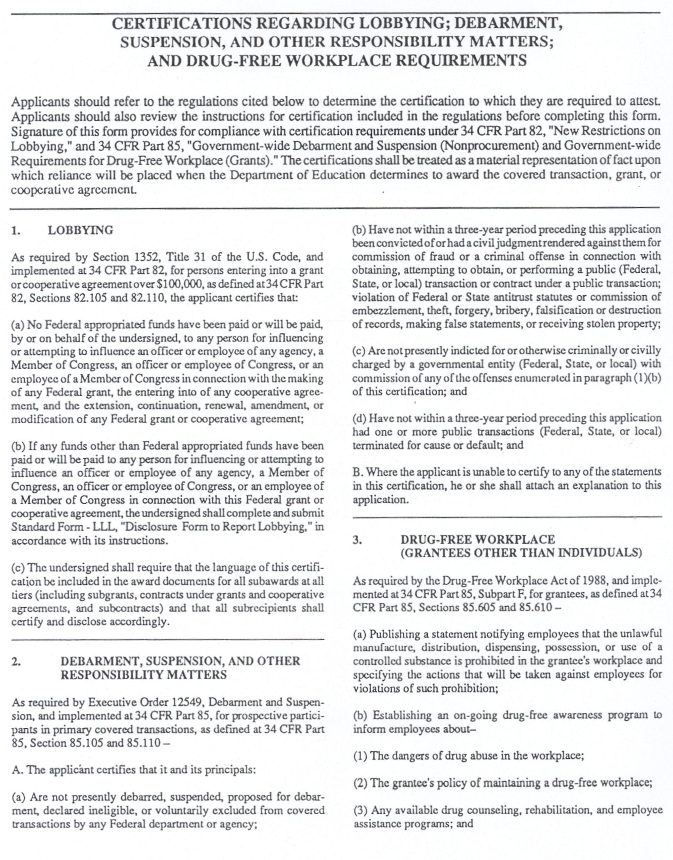

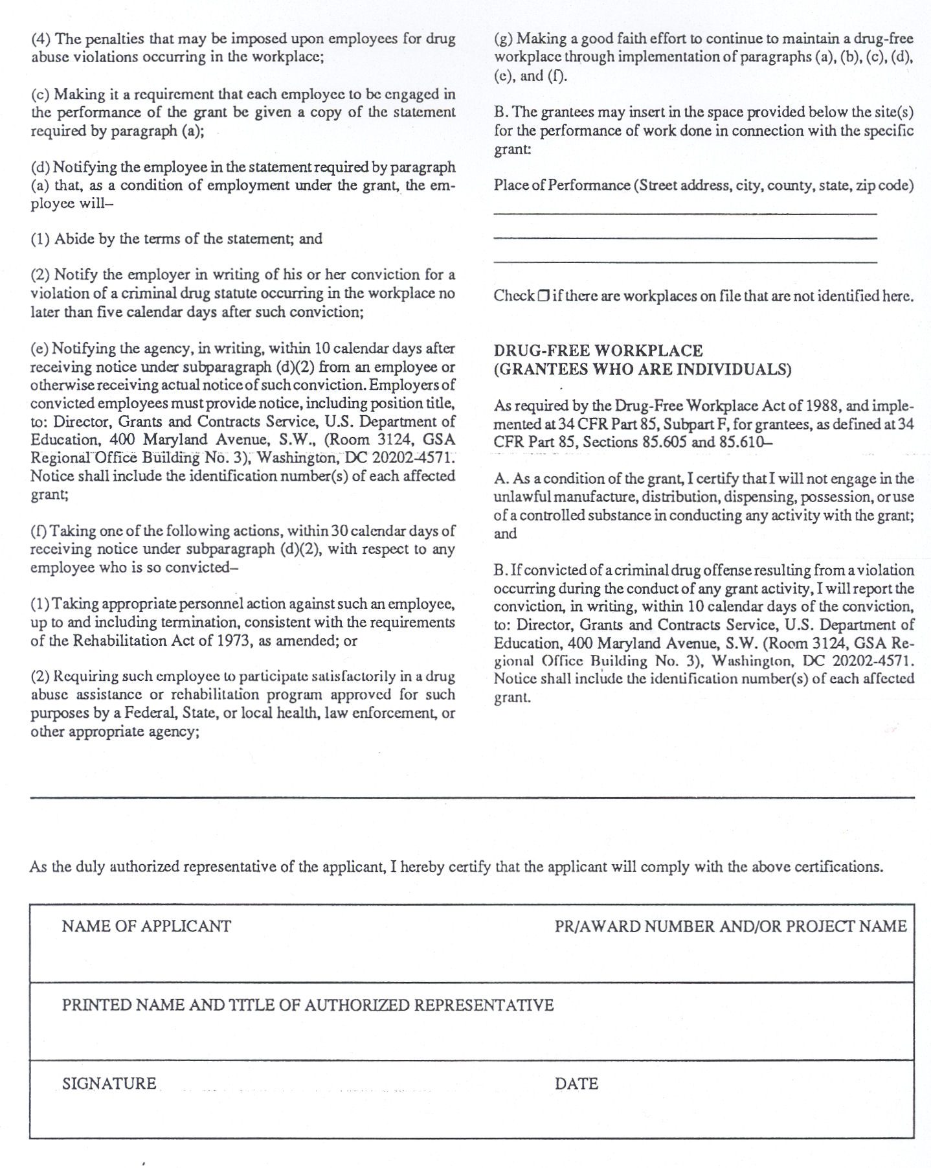

Appendix F

Size, Scope & Quality Programmatic Requirements Chart
(FY 2019 Career and Technical Education Programs)

Institution: Date:

This chart may be duplicated for the appropriate required number of Perkins approved programs. To review your institutions Perkins Eligible programs, please access the Kansas Higher Education Data System (KHEDS) at https://submission.kansasregents.org/login.jsp. If nothing has changed and the program has been submitted previously then you do not need to submit program information again.

Size, Scope & Quality Programmatic Requirements Chart
Size
- Identify Program Name | - CIP Code
- Describe how you will ensure that this program is of sufficient size as to be most effective.
Scope
- Describe how the Program offers Dual Enrollment and/or Articulated Credit Opportunities
- Describe how the Program Aligns with Business and/or Industry
Quality
- Identify Industry Credential, Post-Secondary Certificate or Degree Awarded
- Describe where this program is in the Alignment Process
- Describe how your institution ensures that academics are an integral component of this program.
- Describe this program’s review schedule and process.

Appendix G

PERFORMANCE IMPROVEMENT PLAN FOR UNMET 2016-2017 CORE INDICATORS

Institution: _______________________________

Program Improvement Plan for: Core Indicator: _____________ Institutional Performance: ______________

- Please provide any information or data that may explain why the agency did not meet the 90% performance level for this indicator.

- Clearly describe the institution’s goal(s) for improving performance on this measure, the specific actions to meet the goal(s), and how the agency will measure whether the goal(s) have been met.

- Provide the lead contact for each action item identified under response B.

- Project a date of completion for each action item identified under response B.

- Describe how this local improvement plan was developed in consultation with appropriate agencies, individuals, and organizations (Perkins IV, Section 113(b)(3))

- Describe any budget allocations that will be utilized to support the improvement actions and identify the funding source.

Appendix I Institution: _______________________________
PERKINS PROGRAM IMPROVEMENT ACTIVITY AND PROGRESS REPORT
Academic, Career & Technical Activities
Goal 1: To strengthen the academic and technical skills of students by strengthening the academic and technical education components of programs.

Line #  1 | Description of the Activity | Funding  $
 | Responsibility: Timeline:
 | Evaluation/Measures:
Dec 1
Mar 1
Final
Outcomes

Line #  2 | Description of the Activity | Funding  $
 | Responsibility: Timeline:
 | Evaluation/Measures:
Dec 1
Mar 1
Final
Outcomes

Line #  3 | Description of the Activity | Funding  $
 | Responsibility: Timeline:
 | Evaluation/Measures:
Dec 1
Mar 1
Final
Outcomes

Total Perkins Funding Requested for Goal 1: $
PERKINS PROGRAM IMPROVEMENT ACTIVITY AND PROGRESS REPORT
Articulation/Postsecondary Linkages Activities

Goal 2: To link secondary with postsecondary career and technical education programs and postsecondary career and technical education programs with baccalaureate programs. [Perkins Act: Sec. 135(b)(2)]

Line #  1 | Description of the Activity | Funding  $
 | Responsibility: Timeline:
 | Evaluation/Measures:
Dec 1
Mar 1
Final
Outcomes

Line #  2 | Description of the Activity | Funding  $
 | Responsibility: Timeline:
 | Evaluation/Measures:
Dec 1
Mar 1
Final
Outcomes

Line #  3 | Description of the Activity | Funding  $
 | Responsibility: Timeline:
 | Evaluation/Measures:
Dec 1
Mar 1
Final
Outcomes

Total Perkins Funding Requested for Goal 2: $ j

PERKINS PROGRAM IMPROVEMENT ACTIVITY AND PROGRESS REPORT
All Aspects of Industry Activities

Goal 3: To provide students with strong experience in and understanding of all aspects of their chosen industry. [Perkins Act: Sec. 135(b)(3)]

Line #  1 | Description of the Activity | Funding  $
 | Responsibility: Timeline:
 | Evaluation/Measures:
Dec 1
Mar 1
Final
Outcomes

Line #  2 | Description of the Activity | Funding  $
 | Responsibility: Timeline:
 | Evaluation/Measures:
Dec 1
Mar 1
Final
Outcomes

Line #  3 | Description of the Activity | Funding  $
 | Responsibility: Timeline:
 | Evaluation/Measures:
Dec 1
Mar 1
Final
Outcomes

Total Perkins Funding Requested for Goal 3: $ j

PERKINS PROGRAM IMPROVEMENT ACTIVITY AND PROGRESS REPORT
Use of Technology Activities

Goal 4: To develop, improve or expand the use of technology in career and technical education. [Perkins Act: Sec. 135(b)(4)]

Line #  1 | Description of the Activity | Funding  $
 | Responsibility: Timeline:
 | Evaluation/Measures:
Dec 1
Mar 1
Final
Outcomes

Line #  2 | Description of the Activity | Funding  $
 | Responsibility: Timeline:
 | Evaluation/Measures:
Dec 1
Mar 1
Final
Outcomes

Line #  3 | Description of the Activity | Funding  $
 | Responsibility: Timeline:
 | Evaluation/Measures:
Dec 1
Mar 1
Final
Outcomes

Total Perkins Funding Requested for Goal 4: $ j
PERKINS PROGRAM IMPROVEMENT ACTIVITY AND PROGRESS REPORT
Professional Development Activities

Goal 5: To provide high quality & comprehensive professional development for teachers, counselors and administrators. [Sec 134(b)(4), Sec 135(b)(5)]

Line #  1 | Description of the Activity | Funding  $
 | Responsibility: Timeline:
 | Evaluation/Measures:
Dec 1
Mar 1
Final
Outcomes

Line #  2 | Description of the Activity | Funding  $
 | Responsibility: Timeline:
 | Evaluation/Measures:
Dec 1
Mar 1
Final
Outcomes

Line #  3 | Description of the Activity | Funding  $
 | Responsibility: Timeline:
 | Evaluation/Measures:
Dec 1
Mar 1
Final
Outcomes

Total Perkins Funding Requested for Goal 5: $ j
PERKINS PROGRAM IMPROVEMENT ACTIVITY AND PROGRESS REPORT
Program Evaluation Activities

Goal 6: To develop & implement evaluations of CTE programs, including how needs of special populations are being met [Sec 135(b)(6)]

Line #  1 | Description of the Activity | Funding  $
 | Responsibility: Timeline:
 | Evaluation/Measures:
Dec 1
Mar 1
Final
Outcomes

Line #  2 | Description of the Activity | Funding  $
 | Responsibility: Timeline:
 | Evaluation/Measures:
Dec 1
Mar 1
Final
Outcomes

Line #  3 | Description of the Activity | Funding  $
 | Responsibility: Timeline:
 | Evaluation/Measures:
Dec 1
Mar 1
Final
Outcomes

Total Perkins Funding Requested for Goal 6: $ j

PERKINS PROGRAM IMPROVEMENT ACTIVITY AND PROGRESS REPORT
Improve, Expand & Modernize Program Activities

Goal 7: To improve, expand and modernize quality CTE programs. [Perkins Act: Sec. 135(b)(7)]

Line #  1 | Description of the Activity | Funding  $
 | Responsibility: Timeline:
 | Evaluation/Measures:
Dec 1
Mar 1
Final
Outcomes

Line #  2 | Description of the Activity | Funding  $
 | Responsibility: Timeline:
 | Evaluation/Measures:
Dec 1
Mar 1
Final
Outcomes

Line #  3 | Description of the Activity | Funding  $
 | Responsibility: Timeline:
 | Evaluation/Measures:
Dec 1
Mar 1
Final
Outcomes

Total Perkins Funding Requested for Goal 7: $ j
PERKINS PROGRAM IMPROVEMENT ACTIVITY AND PROGRESS REPORT
Sufficient Size, Scope & Quality Activities

Goal 8: To provide services & activities that are of sufficient size, scope and quality to be effective. [Perkins Act: Sec. 135(b)(8)]

Line #  1 | Description of the Activity | Funding  $
 | Responsibility: Timeline:
 | Evaluation/Measures:
Dec 1
Mar 1
Final
Outcomes

Line #  2 | Description of the Activity | Funding  $
 | Responsibility: Timeline:
 | Evaluation/Measures:
Dec 1
Mar 1
Final
Outcomes

Line #  3 | Description of the Activity | Funding  $
 | Responsibility: Timeline:
 | Evaluation/Measures:
Dec 1
Mar 1
Final
Outcomes

Total Perkins Funding Requested for Goal 8: $ j
PERKINS PROGRAM IMPROVEMENT ACTIVITY AND PROGRESS REPORT
Special Populations Activities

Goal 9: To provide activities to prepare special populations students for high-skill, high-wage, or high-demand occupations that will lead to self-sufficiency.
[Perkins Act: Sec. 135(b)(9)]

Line #  1 | Description of the Activity | Funding  $
 | Responsibility: Timeline:
 | Evaluation/Measures:
Dec 1
Mar 1
Final
Outcomes

Line #  2 | Description of the Activity | Funding  $
 | Responsibility: Timeline:
 | Evaluation/Measures:
Dec 1
Mar 1
Final
Outcomes

Line #  3 | Description of the Activity | Funding  $
 | Responsibility: Timeline:
 | Evaluation/Measures:
Dec 1
Mar 1
Final
Outcomes

Total Perkins Funding Requested for Goal 9: $ j

PERKINS PROGRAM IMPROVEMENT ACTIVITY AND PROGRESS REPORT
Administration

Goal 10: To provide support for the administration of the Program Improvement grant funds (maximum of 5%)

Line #  1 | Description of the Activity (Required for approval) | Funding  $
 | Responsibility: Timeline:
 | Evaluation/Measures:
Dec 1
Mar 1
Final
Outcomes

Total Perkins Funding Requested for Goal 10: $ j

Appendix J
FY 19 Perkins Program Improvement Grant

Proposed Acquisitions of Equipment (Unit Cost of $501 - $4,999)
and
Significant Technology Items

Institution: _____________________________________

Description | Number of Items | Unit Cost | Total Cost | Program & Location (Campus Building)  (Identify by each Item)
Strategic Planning (Wish List)

Appendix K
FY19 Perkins Program Improvement Grant

Proposed Acquisitions of Equipment (Unit Cost of $5,000 or More)

Institution: _____________________________________

Description | Number of Items | Unit Cost | Total Cost | Program & Location (Campus Building)  (Identify by each Item)
Strategic Planning (Wish List)

