**Kansas State University**

**Kansas Blueprint for Literacy**

**ASPIRE Center**

1. **Vision**

The vision of the **A.S.P.I.R.E.** – *Advancing Skills, Promoting Innovation, and Reading Excellence* Center is*:* "Helping learners aspire to greater literacy achievements" which will impact student literacy learning through the delivery of world-class education and educator training in the science of reading (SoR). The ASPIRE Center at Kansas State University will collaborate with identified and emerging partners to ensure Kansas teachers and school leaders are highly skilled in the application of the science of reading, provide support to families, and provide community-based innovative interventions designed to positively impact the unique needs of our catchment area and state.

Kansas State directly serves Catchment Area 2. We are accredited by the Kansas State Department of Education (KSDE) and the Council for the Accreditation of Educator Preparation (CAEP) at the initial and advanced levels (2023). K-State’s College of Education has fully approved P-6 Elementary Education and P-12 Reading Specialist programs by the KSDE.

1. **Pre-Service Educator Preparation:**

**Pre-Service Educator Preparation Current Program**

Kansas State University prepares highly competent teachers for classrooms. Our strong P-12 preparation programs require rigorous coursework, intensive field-based experiences and informative assessments about knowledge and demonstrated skills. The K-State undergraduate elementary education program requires two specific courses: EDEL 411 *Science of Reading I* and EDEL 461 *Science of Reading II* for three credit hours each. Two required practicum experiences include EDEL 410 *Block B Practicum* and EDEL 460 *Block C Practicum* for two credit hours each. Additionally, all students complete a student teaching experience. The KBOR designed common SoR application assessment is conducted formally in the Block B Practicum. Ongoing assessment occurs throughout the field experience sequence through the completion of student teaching. All undergraduate elementary education students also complete EDCI 400 *New Literacies in Contemporary Classrooms*. This course introduces general concepts of new literacies (i.e., the skills, strategies and dispositions needed to adapt to constantly changing information and communication technologies) along with innovative approaches to literacy instruction. In particular, the course focuses on the use of digital tools and multimodal texts to support pillars of reading foundational to the SoR: reading comprehension, written and oral communication, visual literacy, and problem solving in K-6 classrooms. Assessments conducted as part of our accreditation process provide rich evidence of P-6 learning on the part of public school students who learn from teachers who have completed our program.

**Pre-Service Educator Preparation: Success of Program Completers’ Performance on Licensure Literacy Test (ETS code 7812)**

|  |  |  |  |
| --- | --- | --- | --- |
|  | # Completers | # Take 7812 | % Pass 7812 |
| 2021-2022 | 276 | 233 | **95.71%** |
| 2022-2023 | 234 | 177 | **94.92%** |

Note: Completer cohort passing rates recorded up to one year after program completion.

This set of data indicates our completers’ performance on the Kansas approved literacy test (ETS Code 7812). The data show our prepared educators are capable of fostering literacy learning among diverse P-6 students. We observe high passing rates consistently across all licensure pathways (well over 90%). This reflects the effectiveness of our established programs, which are grounded in the SoR and aligned to state and national professional standards, in preparing Kansas teachers and school leaders to provide literacy instruction based on well-established research and in response to the needs of the learners they serve.

Please find evidence (Appendix A) that Kansas State University has aligned our current education and training for pre-service program to the International Dyslexia Association (IDA)

Knowledge and Practice Standards, and the Kansas Educator Preparation Provider

Accreditation and Program Standards for Elementary Education. In the appendices, please find a curriculum map detailing how and when the science of reading is incorporated into our program.

The current fiscal investment to support literacy education, including personnel and resources is approximately $595,688 for FY 2025. See budget for additional information.

**Pre-Service Educator Preparation: Proposed Enhancements**

Through the College of Education, preservice teachers are required to engage in high-quality clinical practice or field-based experiences through effective partnerships with P-12 schools. Our current elementary licensure program requires four formal field experiences of various types prior to the student teaching internship. These experiences are calibrated to begin with guided observations and initial interactions with students, through a service-learning experience, and culminating with two formal practicum placements in partnership schools in which the exposure to and experience with the SoR is an expectation and a requirement. These field experiences are carefully aligned to the SoR content explicitly taught in *Science of Reading I* and *Science of Reading II* that are taken concurrently with the final two formal practicum placements. The results of our program are evident in candidates’ success rates on licensure examinations, the results of our accreditation processes at the state and national levels, our employer and completer satisfaction data, and our various internal quality assurance systems (see data to be provided below). This proposal seeks to build on existing practice, extend our support for catchment area schools, and both document and enhance our practice and the experiences of P-6 students in Kansas schools.

Kansas State University proposes new, innovative initiatives and methods to enhance our current pre-service teacher preparation program. First, clinical and field-based experiences will be strengthened through the addition of microteachings, both with peers and with young students. Virtual support will be provided, as needed. Next, a Literacy Day will be hosted on the KSU campus that will provide teaching and learning opportunities for students and KSU pre-service teachers. Finally, three one-day on-site professional learning opportunities will benefit both pre-service and inservice teachers. These new initiatives will be further discussed in the following sections.

**Pre-Service Educator Preparation:**

**Simulations.** Further refinement of our field-based experiences for teacher education candidates is an essential component of this proposal, as those activities will serve the dual purpose of better training prospective teachers on the application of scientific principles of literacy instruction while concurrently addressing the needs of schools in our catchment area.

Simulations are a form of experiential learning where pre-service teachers practice the skills, strategies, and pedagogy they need in the classroom. Simulations can range from microteaching to student teaching, and forms in between like one-on-one teaching, on-campus literacy enrichment days, or virtual robot observations.

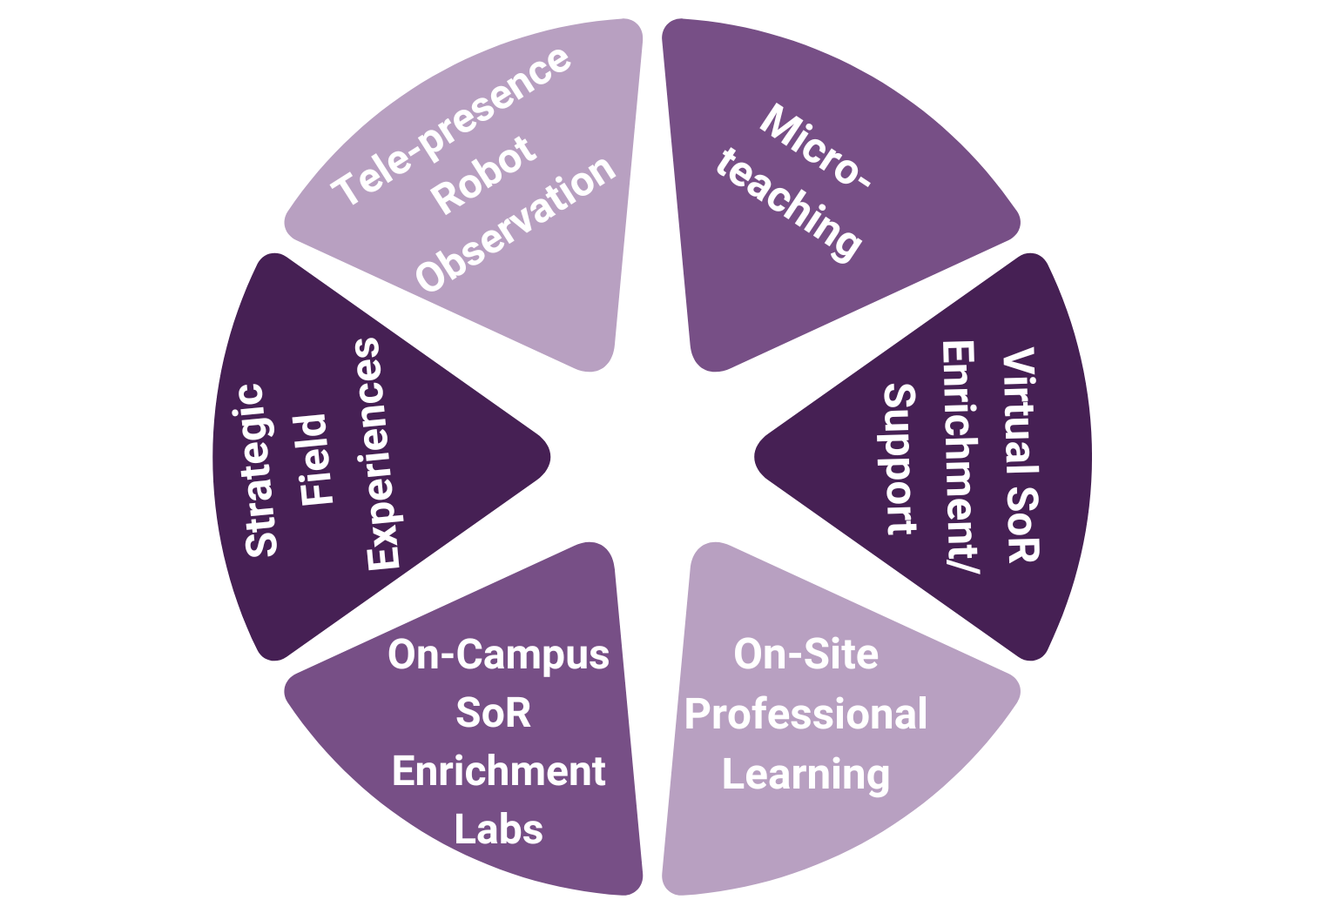

***Microteaching.*** Our proposal draws in part on the promising body of research from the late 20th century developing the practice of microteaching. As it was initially conceived, microteaching tasked pre-service teachers with very specific instructional techniques that they would practice for small groups of P-12 students. Those microteaching exercises were recorded and immediately reviewed and critiqued by mentors after which the teacher in training would repeat the lesson a second time. The second lesson was also recorded and critiqued. Research of the time demonstrated comparable gains in instructional skill from candidates exposed to microteaching as compared to candidates placed in field experiences in P-12 schools (e.g., Metcalf). The current proposal adapts and enhances the original microteaching design in several important ways unique to K-State.

***Virtual SoR Enrichment/Support.*** While microteaching was originally intended strictly as a learning experience for pre-service teachers, our design seeks to use this model to deliver vital SoR enrichment to elementary students in the catchment area. School districts and parents within the catchment area will be able to enroll their students for literacy enrichment and support. Under the guidance of our faculty, our preservice teachers will deliver structured literacy lessons focused on discrete components of the SoR. In this manner, districts will receive additional support for their students’ learning while our teacher candidates rehearse critically important instructional skills. Our third-party solution for remote supervision, GoReact, will provide a secure digital platform through which video recorded teaching performances can be stored, analyzed and critiqued. This service will be delivered virtually and aligns with districts’ need for Tier 2 intervention support for literacy. Exemplars will be used to enhance knowledge in required methodology courses.

***On-Site Professional Learning.*** The center will also leverage the microteach model within professional learning opportunities offered to both pre-service teachers and in-service teachers. Faculty will guide pre and inservice teachers through in-person professional learning pertaining to the SoR. These one-day on-site professional learning opportunities will be offered three times per year at three central locations within the catchment area.

***On-Campus SoR Enrichment Labs.*** Schools within the catchment area will be recruited to enroll their students and teachers in a day of literacy learning at Kansas State University. These workshops will be led by preservice teachers who will engage elementary students in SoR focused literacy enrichment, while in-service teachers receive training in SoR practices by our faculty to develop enhanced application skills to meet the varied needs of learners.

***Strategic Field Experiences.*** Whenever possible, we will continue to collaborate with the districts within our catchment area to cultivate unique field experiences for our preservice teachers to observe and practice SoR literacy instruction. (Naturally, this collaboration is contingent upon willing participation on the part of the districts in the defined area.) We conceptualize these experiences as being a combination of virtual and in-person, depending on our candidates’ geographic location and the needs and capacity of partner districts.

***Telepresence Robots.*** To support our new catchment area schools, we propose leveraging telepresence robots—a proven strength of K-State’s educational technology with multiple peer reviewed presentations and publications on the topic. Having used telepresence robots successfully in student teaching and early field experiences, we aim to extend their impact by using existing robots already deployed in some catchment area schools and exploring opportunities to add more. These robots offer teacher candidates unique, immersive experiences in classrooms, allowing them to engage with students and teachers directly, even in remote areas. This approach enhances access to diverse educational settings, facilitating a deeper understanding of rural and urban educational dynamics. By scaling this initiative, we will provide teacher candidates with broader, real-time classroom interactions that bridge geographic gaps, preparing them to teach in a variety of school environments.

In all of these proposed activities, our undergraduate elementary education students enrolled in required courses–*Science of Reading I* and *Science of Reading II*-will have the opportunity to work with elementary students drawn from schools in our catchment area, and in-service teachers will be able to engage in ongoing professional learning on the SoR. In this manner, districts can receive additional support for their students’ learning while our teacher candidates rehearse critically important instructional skills, and in-service teachers engage in continuous learning. As mentioned above, our third-party solution for remote supervision, GoReact, will provide a secure digital platform through which video recorded teaching performances can be stored, analyzed and critiqued for improved instructional practice that leads to positive student outcomes. The use of emerging AI technology will be explored to augment feedback. The microteaching component of this proposal affords a powerful means of technology integration within a context meaningful to teacher candidates and partnership teachers and students. These innovative approaches will allow us to model powerful instances of next-generation technology use in P-16 environments.

**III.** **Inservice Educator and District Programs/Support**

A variety of opportunities for inservice educators will be designed and delivered by the Center. Graduate level courses in the science of reading will continue to be offered.

**In-Service Educator and District Programs/Support: Current Program**

K-State offers robust coursework leading to a reading specialist license from KSDE, both as an endorsement for those who hold a Master’s degree and a Master’s degree in Curriculum and Instruction with a Reading Specialist focus. Current literacy-specific courses include: EDCI 816 Approaches to Literacy Instruction; EDCI 818 Theoretical Models of Literacy; EDCI 840 Literacy Assessment; EDCI 841 Striving Literacy Learners; EDCI 930 Leadership in Literacy; and EDCI 945 Clinical Practicum in Reading. Currently, K-State offers a microcredential and two graduate-level courses in partnership with the Phillips Fundamental Learning Center. The microcredential is offered eight times each year. The coursework is offered each semester.

Our faculty are constantly requested for district-level professional development on ways to meet the literacy needs of all students, including English learners, and continue to enhance their own knowledge of literacy instruction through professional memberships and conferences and their own research. This expertise is leveraged in the coursework they teach.

**In-Service Educator and District Programs/Support: Simulations**

In-service teachers face increasing demands to adapt to diverse student needs and emerging instructional methods. Simulations offer a dynamic learning experience where teachers can practice responding to realistic scenarios, make decisions, and immediately see the consequences of their actions. As mentioned before, simulations are a form of experiential learning and in-service teachers have the advantage of having their own classrooms and students for practice, with This hands-on approach helps teachers reflect on their practices and develop more effective strategies that they can apply directly in their classrooms. Authentic, real-world scenarios will be developed through collaboration with local schools and based on current classroom challenges to ensure teachers are equipped to respond to the unique literacy needs of learners. Teachers will engage with these scenarios through a variety of interactive formats, including role-play, case studies, and online platforms.

Our in-service plan integrates various forms of experiential learning/simulations for in-teachers. Taking an integrated approach, our plan is founded on the use of Literacy Coach Fellows to provide coaching and feedback to in-service teachers across various contexts. This includes integrating the microcredentials into the Program of Study for Reading Specialist Endorsement and Master’s degree using the Literacy Coach Fellow to provide extensive coaching and feedback. Our Literacy Coach Fellows will also support educator’s action research projects in literacy. Enclosing this work is the strategic support for ESOL learners.

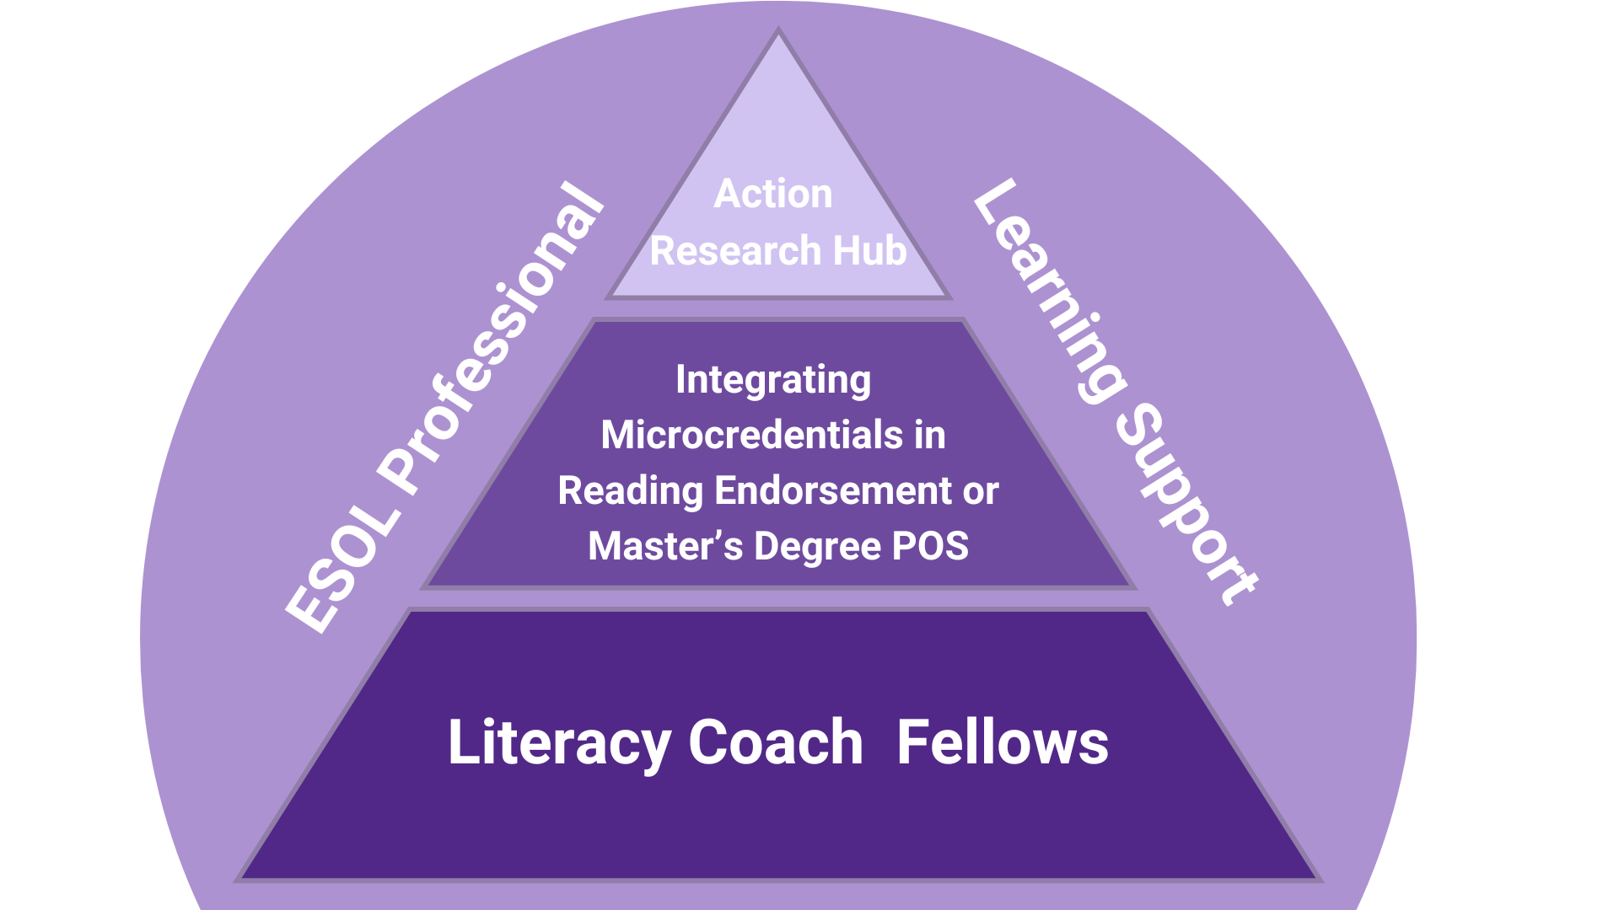

***Integrating Microcredentials in Reading Endorsement or Master’s Degree POS***

On-going professional learning in the science of reading (SoR) equips teachers with research-backed knowledge on the core components of reading instruction—phonemic awareness, phonics, fluency, vocabulary, and comprehension. These elements are crucial for effective literacy instruction, particularly for early readers and students with reading difficulties. The KBOR Blueprint for Literacy provides for a microcredential in SoR that could look like Science of Reading I and II at a graduate level. To encourage in-service educators to select the KBOR sponsored microcredential, our Center proposes integrating the microcredential into our existing Reading Specialist endorsement and Master’s in Curriculum and Instruction with a Reading Specialist focus. The courses would be offered through Curriculum and Instruction, however the courses would utilize the Literacy Coach Fellows to provide ongoing coaching and feedback. The program of study for both the endorsement and the Master’s degree can be found in Appendix B.

**In-Service Educator and District Programs/Support: Coaching**

***Literacy Coach Fellows.*** The Center seeks to improve literacy instruction and outcomes across diverse educational settings by leveraging the expertise of Kansas Reading Specialists. To achieve this, the Center proposes the establishment of a Literacy Coach Fellows Program, initially drawing from currently licensed Kansas Reading Specialists. These Fellows will be trained and supported to become Literacy Coaches, enabling them to mentor teachers, implement research-based literacy strategies, and lead literacy initiatives within their schools and communities. The Literacy Coach Fellows will be pivotal in enhancing literacy instruction, particularly in underserved areas within our catchment area. Research consistently shows that literacy coaches are instrumental in improving classroom literacy instruction and student reading performance by providing ongoing professional development, modeling effective teaching practices, and fostering collaboration among teachers (Bean & Ippolito, 2016; Walpole & McKenna, 2017). Research to support Literacy Coach Fellows can be found in Appendix C.

An annual summit to support school leaders and the Literacy Fellows will be held. This day of professional learning will focus on the specific needs of school leaders in supporting literacy learning within their schools and communities. It is critical that school leaders support their Literacy Fellows, teachers and paraprofessionals.

The Literacy Coach Fellows Program will have the following objectives:

* Enhance Literacy Instruction: Equip Literacy Coach Fellows with advanced knowledge and skills in the science of reading, structured literacy, and evidence-based practices in response to learners’ identified assets and needs.
* Build Teacher Capacity: Empower Literacy Coaches to mentor and support classroom teachers in their own schools, fostering professional development and improved literacy instruction.
* Promote Literacy Equity: Focus on addressing literacy gaps in underserved and marginalized communities through culturally responsive and inclusive literacy practices.
* Foster Research and Innovation: Engage Fellows in action research projects to test, refine, and share literacy interventions with the broader educational community.
* Sustain Literacy Improvement: Develop long-term literacy leadership by creating a network of skilled Literacy Coaches who can sustain and scale effective literacy practices within their schools and districts.

### Program Structure: The program will recruit currently licensed Kansas Reading Specialists within our catchment area who have demonstrated leadership potential and a strong commitment to improving literacy outcomes. Candidates will be selected based on their literacy instruction experience and ability to mentor and support fellow educators. The program will prioritize candidates from underserved and rural communities to ensure the greatest impact is made in areas with significant literacy challenges.

Professional Development

* Initial Intensive Training: Fellows will participate in an institute focused on refreshing their knowledge of the science of reading, structured literacy, culturally responsive teaching, and coaching strategies.
* Ongoing Professional Development: Throughout the year, Fellows will attend professional development sessions to deepen their knowledge and refine their coaching skills
* Coaching and Mentorship
* Upon completion of initial training, Fellows will serve as Literacy Coaches for teachers in the Center’s catchment area - both in-person and virtually.
* Collaborative Inquiry: Fellows will lead PLCs where teachers collaborate on literacy-focused action research, share strategies, and reflect on data to drive continuous improvement in literacy outcomes.
* Research
* Fellows will be involved in research on the process and impact of coaching for literacy

***ESOL Professional Learning Support.*** The College of Education at Kansas State University has for the last 30 years been at the forefront in the preparation of pre-service and in-service teachers in identifying the assets and meeting the needs of students who do not speak English as their native/first language. Through the development of microcredentials that will be shared, the Center will provide innovative routes for increasing educators’ knowledge, skills, and application of SoR for culturally and linguistically diverse learners. The microcredentials will be available at a nominal cost to districts and individuals.

***Action Research Hub.*** An Action Research Hub within the Center will enhance literacy instruction by integrating the science of reading, structured literacy, and evidence-based instructional practices. (See appendix D for research to support this component of ASPIRE). Action research is another area of strength for K-State as evident by *Networks: An Online Journal for Teacher Research* that is hosted at New Prairie Press which is housed in Kansas State University Libraries. Currently edited by Dr. Suzanne Porath, this journal has been publishing Open-Access, peer-reviewed articles for 25 years. In addition, our faculty have written an Open-Access textbook entitled Action Research (Clark et al., 2020) which has been adapted and adopted at other institutions.

**Areas of Focus:**

* **School-Based Action Research Groups**
  + Collaborative teams of educators within a school engage in systematic inquiry to address specific challenges in their literacy teaching practices. These groups identify a problem, implement strategies, collect data, and reflect on outcomes, promoting continuous improvement in instruction and student learning.
    - K-State had strong success during the KLink grant with research groups in USD 383. Numerous educators presented and published in national conferences and journals.
  + These groups will be facilitated by Center personnel.
* **Cross-School Action Research Networks**
  + Virtual Action Research Communities - Create an online platform where educators from different schools can collaborate, share research progress, and access resources. Regular virtual meetings or forums can allow participants to exchange findings and refine their action research projects in real-time.
  + Annual Action Research Symposium - Host an annual conference or symposium where educators present their action research findings, share successful strategies, and discuss challenges. This event can serve as both a celebration of progress and a learning opportunity for future projects.
  + Mentorship Pairings for New Researchers - Pair experienced teachers who have conducted action research with those new to the process. This mentorship would guide novice researchers through identifying literacy challenges, implementing interventions, and collecting data.
* **Pre-Service Educator Action Research Support** 
  + Develop and implement an affordable micro-credential for pre-service educator action research in literacy. Pre-service educators receive training on the principles of action research, including how to identify classroom challenges, develop research questions, implement interventions, collect data, analyze, and write up research.
  + Support pre-service educators in disseminating research findings
* **Community-Based Participatory Action Research (CBPAR) in Literacy** 
  + CBPAR is a collaborative research approach that actively involves community members, researchers, and stakeholders in the entire research process to address local issues or challenges to increasing the literacy of diverse student populations. This method emphasizes shared ownership of the research, equal participation, and the use of research findings to drive social change and improve community outcomes (McIntyre, 2008). The Action Research Hub could play a crucial role in supporting CBPAR by providing resources, expertise, and a structured framework for collaboration between researchers, educators, and community members. This anticipated to emerge from the work of the Parent and Family Advocate. The Hub could offer this support in a variety of ways:
    - The Action Research Hub would help form partnerships between community members, educators, local organizations, and researchers. This could involve identifying community needs, aligning research objectives, and ensuring that all participants are co-owners of the research process.
    - The Hub can provide access to literacy specialists, action research mentors, and experienced researchers who can guide the community and educators through the research design, implementation, and reflection stages.
    - The Hub would support the dissemination of research findings to both the community and wider audiences, ensuring that the results are accessible and actionable for community members and stakeholders.

**In-Service Educator and District Programs/Support: Assessment and Evaluation Services**

We propose a plan for supporting in-service educators and district-based specialists in addressing literacy assessment and evaluation needs for P-12 students. The plan focuses on building a Professional Learning Community including reading specialists, literacy coaches, school psychologists, speech pathologists, and classroom teachers, ensuring a coordinated approach to literacy support. We will form catchment area teams that meet regularly to identify literacy assessment challenges they face with the Diagnostic Expert. The Diagnostic Expert integrated into a Professional Learning Community (PLC) would enhance literacy outcomes by guiding teachers and specialists in using literacy assessments effectively. The expert would support educators in administering and interpreting assessments, ensuring data-driven strategies to address students' specific literacy needs. The diagnostic expert would also support districts’ multi-tiered system of support (MTSS), offering tailored support for students, from classroom-based strategies to intensive, individualized plans. Collaborating with specialists like speech pathologists and school psychologists, the Diagnostic Expert would ensure comprehensive literacy interventions that address both academic and related cognitive or speech challenges. We will call upon the expertise of the READing Center at Pittsburg State University as we begin to offer diagnostic services to students and families. We will also provide educators across the state with technology tools to support enhanced communication with parents and caregivers.

**IV. Personnel**

We propose to appoint an interim director to begin the work in the spring. This individual will be reassigned from their current duties. We will hire an administrative assistant as soon as possible to lead and coordinate the center planning responsibilities. We will then appoint a permanent director in a timely manner. A parent and family advocate and an ESOL expert will be hired during the spring 2025 semester to begin work on professional learning opportunities for educators and families. This core team, in partnership with K-State faculty and our school and community partners will begin work on the specifics of our plan. After the identification of a director and administrative support, we will conduct a school-based needs assessment. This will allow us to more completely understand what the Center needs to provide to meet the needs of the schools in our catchment area. Additional faculty and staff will be identified as the Center grows. See Appendices E & F for additional detail about proposed ASPIRE personnel.

**Planning Year Personnel**

***Director*** *-* Provides overall leadership and direction for the Center. Works with school leaders to determine services needed. One full-time equivalent (FTE) is needed to begin this work.

***Administrative Assistant*** - Provides logistical and technical support for all center employees.

***Parent and Family Advocate*** - Point of contact for parents, families and caregivers. Helps them navigate Center resources, as well as resource partners within our catchment area.

***ESOL Professional Development Specialist*** - Provides professional development support for English Learners, educators, and leaders.

***Communications and Marketing Specialist -*** Design and deliver communications to multiple audiences highlighting services, resources and impact of the Center. Half-time position.

***Technology Infrastructure -*** Computers, ipads, and other technological devices will be purchased to support the work of Center professionals.

***Space*** - Space will be allocated within Bluemont Hall, home to the College of Education

**Year 2 Personnel.** Additional positions to be hired in Year 2

***Microcredential Literacy Coach*** - Supports in-service teachers by providing detailed feedback for simulation and field-based instruction.

***Diagnostic Expert*** - Serves as the primary diagnostician, working directly with students to pinpoint areas of concern and works with teachers on individual strategies.

***Reading Specialist*** - Will support preservice and inservice professional development

**Space -** Space will continue to be allocated on the Kansas State University campus, within the College of Education. Further, space will be reserved at various partners for in-person professional development for educators and leaders, diagnostic activities for students and to meet with and support families.

**Diagnostic and Support Resources** - Resources will be available for in-service teachers, as well as families. Resources will include both print and online resources. Some will be collaboratively developed by center personnel and partners, while others will need to be purchased.

**Year 3 Personnel.** Additional positions to be hired in Year 3

***Diagnostic Expert with ESOL student expertise-*** Serves as the primary diagnostician, working directly with students to pinpoint areas of concern and works with teachers on individual strategies.

**IV.** **Outreach (Partnerships and Families)**

**Outreach - Partnerships and Families: Existing and Future Partnerships**

Partners will be critical to achieve the mission of the ASPIRE Center. Community colleges, independent institutions and community organizations have been contacted and stand ready to partner. Existing partnerships exist with Manhattan Christian College (MCC). A MOU has been in place for many years that allows MCC students to complete a degree in elementary education through K-State. As catchment area #2 is largely new to K-State, new partnerships will be critical. We have reached out to the following institutions/organizations in our area including:

|  |  |  |
| --- | --- | --- |
| Type | Institution/Organization | Contact |
| Community College | Cloud County Community College - | Tonja Bisnette |
| Community College | Barton County Community College | KellyAnn Bonnell |
| Private/Independent | Kansas Wesleyan | Vicki Schmidt |
| Private/Independent | Bethany College | Allen English |
| Private/Independent | Sterling College** | Rachel Wannamaker |
| K-State partners | Early Childhood Program | Jennifer Francois |
| K-State partners | K-State 105: Research and Extension | Gregg Hadley |
| K-State partners | K-State 4-H | Sarah Maass |
| K-State partners | Vice President of Community Engagement | Tim Steffensmeier |
| Community-based | Phillips Fundamental Reading Center | Jeanine Phillips |
| Community-based | READing Center, Pittsburg State University | David Hurford |
| Community-based | North Central Library System | Sandy Wilkerson |

**declined to participate at this time due to leadership transitions, however, we remain in communication with Rachel.

Partnership include independent colleges with an accredited educator preparation program, Kansas Wesleyan; community colleges Barton County Community College and Cloud County Community College) and technical colleges (Manhattan Area Technical College) offering accredited programs in early childhood education; and community-based education partners (Kansas Educational Leadership Institute, K-State Research and Extension - K-State 105, Kansas 4-H, North Central Library System, Phillips Fundamental Learning Center, Center for READing at PSU and the Kansas Central Library System) forty-one local school districts in our catchment area; and other partners as needs arise. These key partnerships and collaborations will ensure equitable access to services and supports throughout the catchment area by serving as physical locations for services, including diagnostic services.

**Outreach - Partnerships and Families: Partnerships and Families: Current and Planned Student/Family Support**

*Needs Assessment.* As part of the Center activities, K-State will conduct a systematic process to identify and analyze literacy needs of students, educators and communities in catchment area #2. This needs assessment will gather information from stakeholders in the region to better understand current strengths and challenges, as well as local contexts, related to literacy. We aim to use a combination of online surveys and focus groups to gain insights from the partners. Outreach to local libraries throughout the catchment area will create the foundation for community engagement to reach all families, including those of English learners. This feedback will be critical in further developing professional learning opportunities in the catchment area. Results from the needs assessment will also contribute to the framework for ongoing evaluation of the Center to ensure services remain responsive to the evolving needs of these communities. Kansas. The Center plans to partner with the Kansas 4-H system to provide community-based literacy events. As an initiative for Kansas 4-H, promotion of reading will be a state-wide endeavor. Additionally, the partnership will provide planned programming for individual clubs. Further, through the K-State 105 network, physical site locations are available for outreach events in all 105 counties. See Appendix G & H for additional partnership details.

**VI.** **Quality Assurance System**

The College of Education at KSU maintains a robust Quality Assurance System (QAS) that consists of valid data from multiple measures and sustains evidence-based continuous improvement (Figure 1). The system is developed and operated with input from internal and external stakeholders. We leverage on-going data collection and real-time analysis to establish priorities, enhance program elements, and highlight innovations. The QAS provides quality assurance and continuous improvement to all initial- and advanced-level licensure programs that lead to a literacy-related educator license. The QAS represents our highest commitment to deliver world-class educator preparation in SoR. The QAS systematically ensures the preparation of knowledgeable, ethical, and caring teachers and school leaders who are highly skilled in the application of the SoR, in support of families, and in providing community-based interventions designed to meet the unique needs of our catchment area, the state, and the nation.

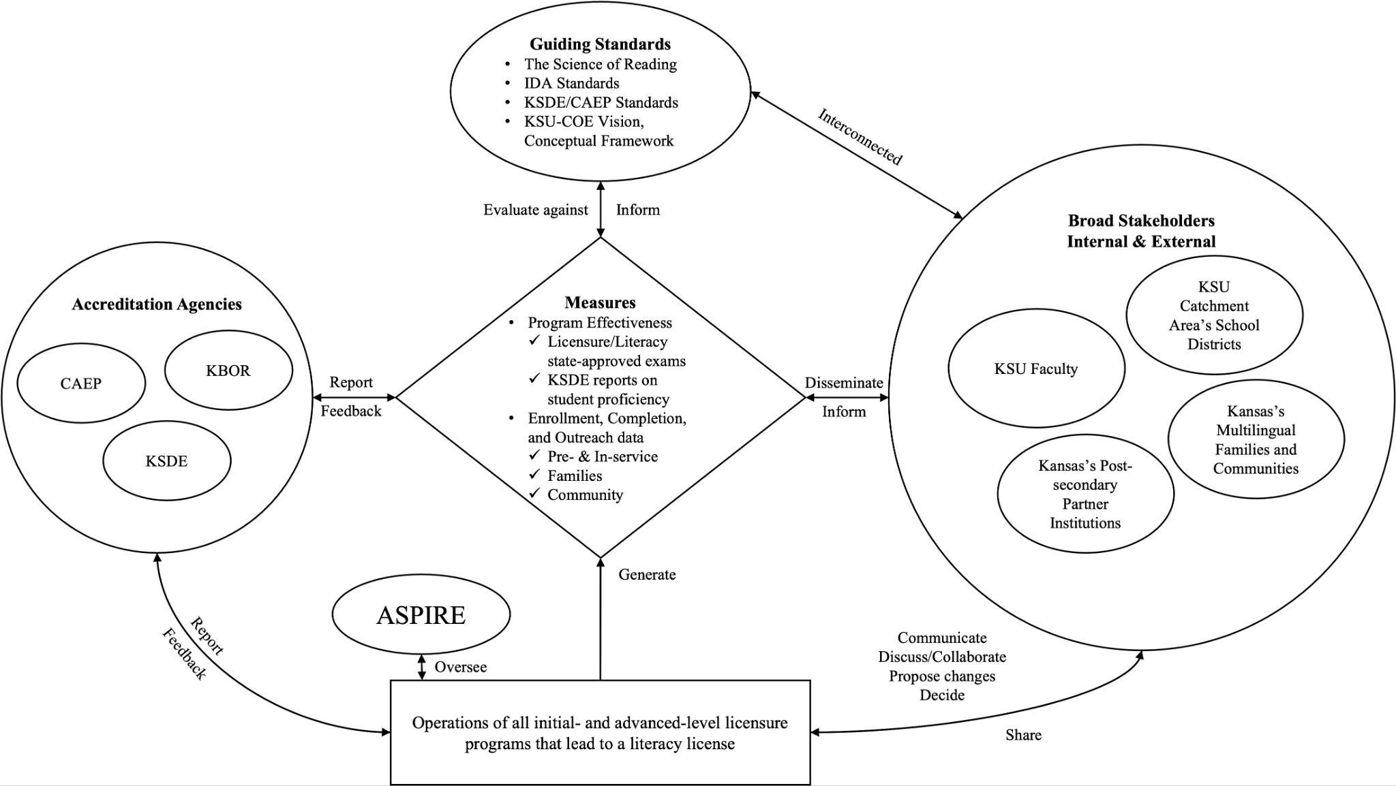

Figure 1. ASPIRE Center’s Quality Assurance System

**Quality Assurance System: Data Collection, Analysis and Quality**

At its core, the QAS relies on relevant, verifiable, representative, cumulative, and actionable measures to ensure interpretations of data are valid and consistent. The QAS utilizes the Program Effectiveness measures, as described. These include (1) the numbers/percent of pre-service candidates meeting the standard on the state approved licensure exam; (2) numbers/percent of elementary special educators, school psychologists, reading specialists, and elementary administrators completing state approved training (e.g., programs offered by the Center), or passing state-approved literacy exam; and (3) KSDE reports on total number and percentage of students performing at a level 1 on the Kansas Assessment for English Language Arts in the designated catchment area, as well as reports on the total number and percentage of students performing at a level 2, level 3, and level 4 on the Kansas Assessment for English Language Arts in KSU’s designated catchment area..

The QAS leverages additional measures on pre- and in-service educator enrollment (e.g., in micro-credential programs), completion, and outreach data. These include numbers of candidates enrolled and completing the Science of Reading/Structured Literacy Foundations 1 and 2 courses, numbers of candidates passing the KSU College of Education’s (the EPP) common performance assessments, which are psychometrically robust and are frequently examined for validity and reliability, at 80% or higher, and numbers of teacher candidates passing the Structured Literacy Licensure exam (ETS Praxis subtest 7002).

The QAS leverages numbers of in-service educators enrolled in the Science of Reading Micro-credentials offered by the ASPIRE Center, and numbers of in-service educators successfully completing the Micro-credential awarded by the Center. Finally, the QAS records and operates with data on numbers and types of services provided to families of the KSU’s designated catchment area, numbers of consultations with school district personnel, numbers of assessments and evaluations completed by these stakeholders, and finally the types and frequencies of the Center’s community outreach.

***Stakeholder engagement.*** As the QAS operates, the ASPIRE Center engages relevant internal and external stakeholders in program design, evaluation, and continuous improvement processes. The engagement is facilitated through formal, periodically stakeholder meetings and events, as well as on-going communications via various channels. Our internal stakeholders consist of the KSU faculty that are involved within and beyond the Center. These are key personnel in designing, evaluating, and continuously improving our program offers, family and community outreach, and the operation of the QAS itself using data generated from the measures specified in the previous subsection.

Through the QAS, the Center works closely with our external stakeholders, also in designing, evaluating, and continuously improving every aspect of our operation. The external stakeholders include school districts in KSU’s designated catchment area (listed below), partner post-secondary institutions (e.g., community colleges and independent institutions), and finally Kansas’s multilingual families and communities that our work endeavors to serve across Kansas. The data generated from the QAS’s robust measures are disseminated to these various groups of stakeholders, where we seek feedback from them and/or further suggestions on ways to co-construct our program offers and continuous improvement.

***Continuous improvement.*** The ASPIRE Center regularly, systematically, and continuously tracks and assesses its performance against the IDA Knowledge and Practice Standards, the Kansas Educator Preparation Provider Accreditation and Program Standards for Elementary Education, and the vision/conceptual framework of the KSU College of Education, using timely and robustly generated data, as well as via co-construction and collaboration mechanisms with our internal and external stakeholders.

All the data, feedback/suggestions, and decisions collectively made by the Center’s stakeholders are properly documented and regularly monitored. The KSU College of Education and the ASPIRE Center have allocated personnel dedicated to these tasks. In fact, the KSU College of Education is in the process of recruiting a new data staff member, who will bring in invaluable expertise in data-informed organizational management to support our continuous improvement efforts. We also have plans to recruit personnel designated specifically to the continuous improvement process of the Center.

Finally, the Center’s QAS is integrated into the KSU College of Education’s accreditation processes. As a result, we continually report to and receive feedback from accreditation agencies, which provide a venue to cross-check all aspects of our operation and continuous improvement.

**Quality Assurance System: Impact Measures**

New programs and initiatives will positively and significantly impact educators, students, and families throughout catchment #2. The unit has the capacity to systematically collect, analyze and review data relevant and designed to measure impact of P-12 literacy outcomes. The ASPIRE Centerwill submit the following data to demonstrate the effectiveness of programs and outreach efforts:

1. Number and percent of pre-service candidates meeting the standard on the state approved licensure exam.
2. Number and percent of elementary special education, school psychologist, reading specialist, and elementary administrators completing state approved training or passing state-approved literacy exam.
3. Performance (Data source – KSDE)
   1. Report on total number and percentage of students performing at a level 1 on the Kansas Assessment for English Language Arts in the designated catchment area.
   2. b. Report on the total number and percentage of students performing at a level 2, level 3, and level 4 on the Kansas Assessment for English Language Arts in the designated catchment area.